Lex Testing 13.8.26
- Need to be able to delete ideas. Currently no way to do that.
- For the diagnosis the input goes from either/or (LP OR MP) to in diagnosis being fill in the MP only. Not a major problem just inconsistent. Lex effectively just says “over to you” at this point. It would be good to have a tips / hint at the top encouraging dictation “Dictating is a faster way to get your ideas down and Lex can tidy up your thoughts.” As long as Lex and MP are working well, which is not necessarily the case at the moment for this page.Guid

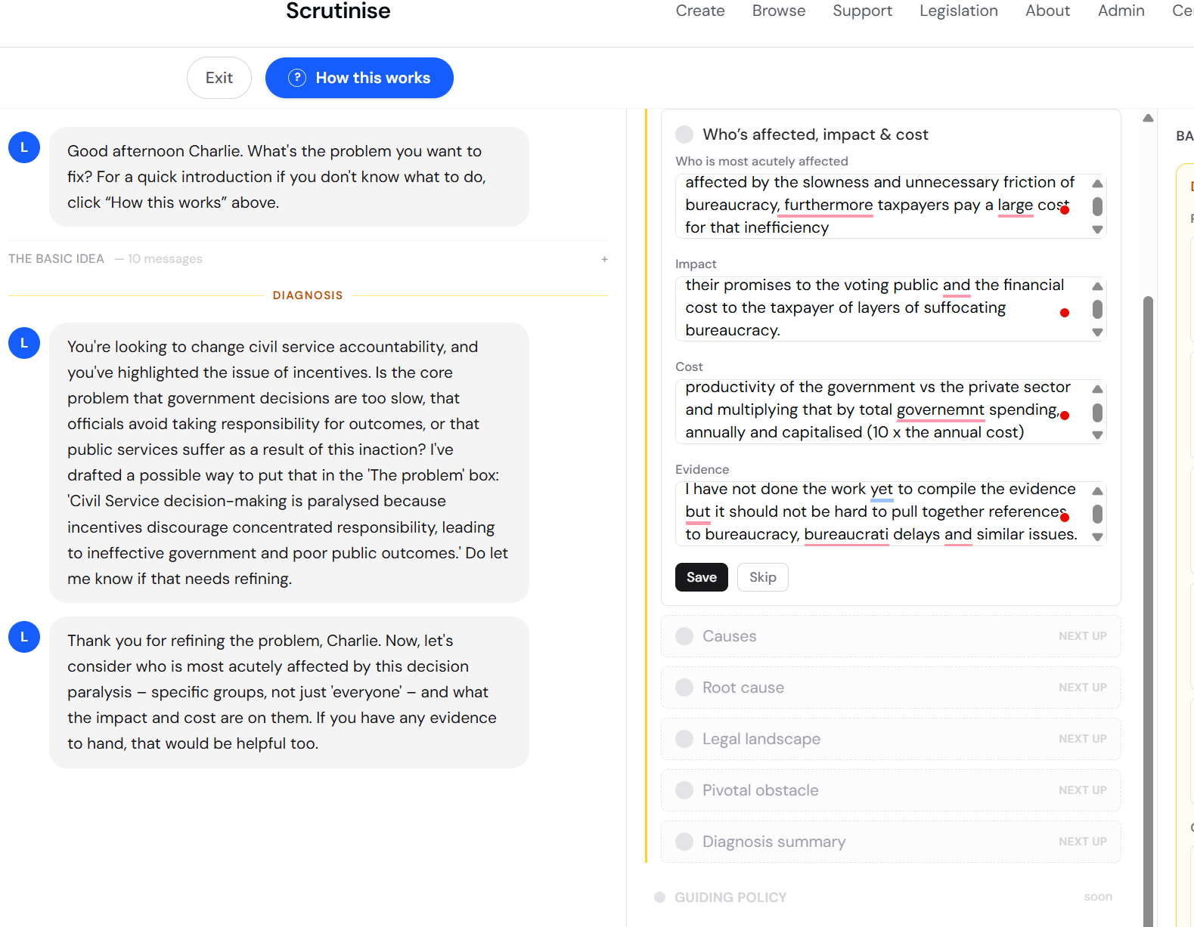

Guiding Policy
This is good

This next section is good: Lex goes through and makes suggestions for 4 fields at once. The only issue here is only 2.5 lines are visible in the UI. The fields need to be large so you can read everything lex has written without scrolling:
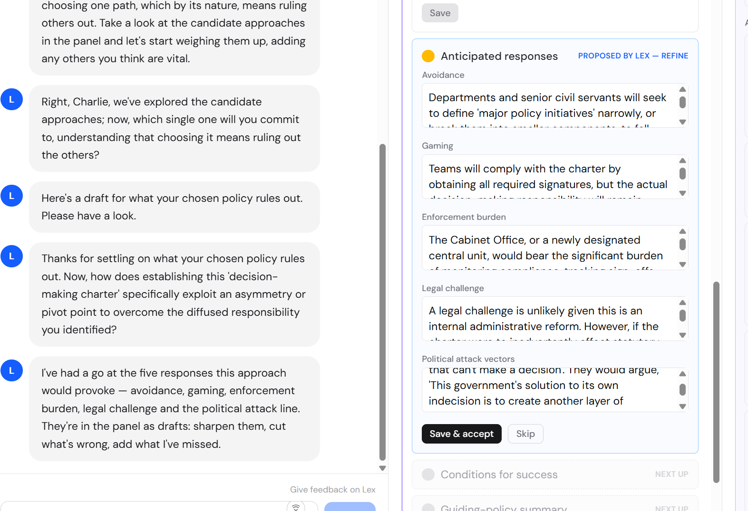
Here too we are missing a simple resizing anchor to increase or decrease the size of the editing window:

This Lex suggested response seems to have had chunks cut out of it at random?
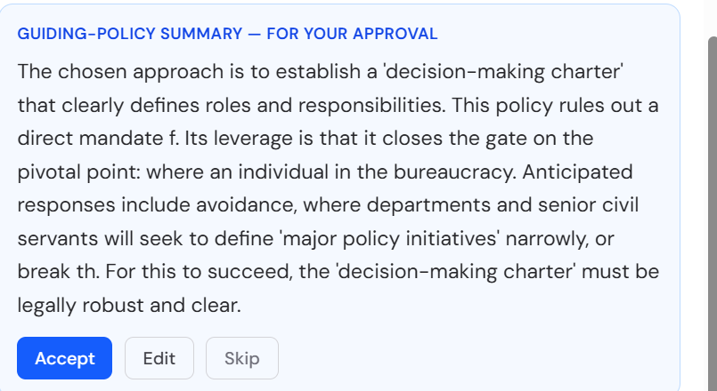

Lex should be fairly firm in the importance of reading the links given and giving an opinion on those.
This link didn’t work:
https://committees.parliament.uk/writtenevidence/121125/
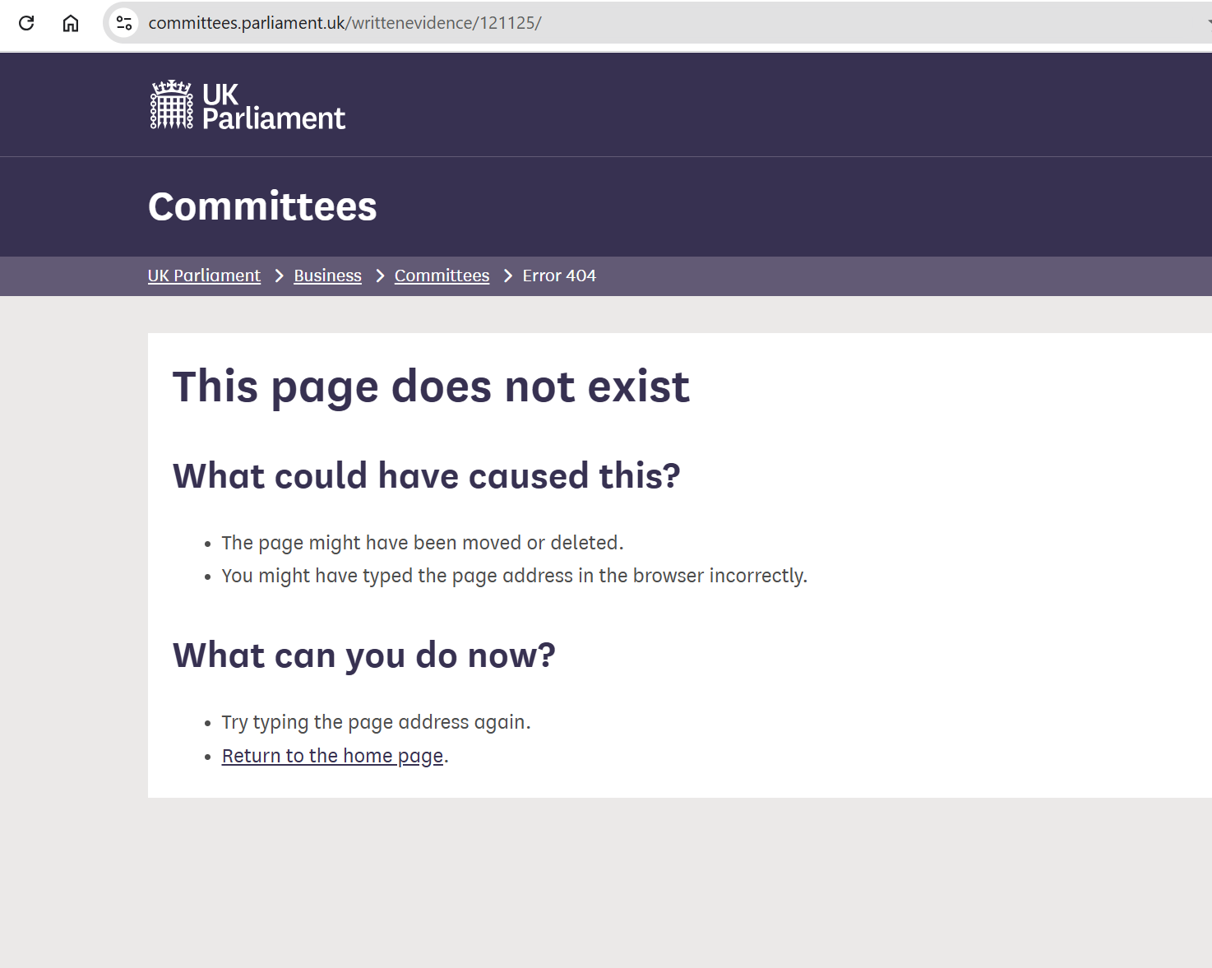
I’ve questioned Lex here and have not received anything like the quality of answer I am used to expecting from a normal Claude or Gemini response. Compare this response from Lex (which should have stuck to answering the question properly rather than pointing at the links and rewriting the answer.
The Lex response:
“:
I don't know if we need a "Charter". Is that the right instrument? How is accountability dealt with at the moment within the Civil Service? Is anything written down? Is there anything about this in the Civil Service code? Or is it completely unwritten an left to the senior civil servants to define success and failure? You seem to have had chunks cut out of your response could you check and reinstate them? It needs to be legally robust and clear.
L
That's a very good question about the 'Charter' and how accountability is currently structured, Charlie. The corpus search, which you can see in the right-hand panel, has brought up several references that might shed light on this, such as the 'Constitutional Reform and Governance Act 2010', the 'Civil Service Leadership and Reform' committee report, and the 'Public Service (Ethics, Integrity and Independence) Bill'. These could be useful for understanding the existing framework. I've drafted a summary of your guiding policy, bringing together your chosen approach, its leverage, what it rules out, anticipated responses, and conditions for success. It includes the point about legal robustness and clarity, as you just emphasised. Please review it in the panel and let me know if it needs any adjustments.
Guiding-policy summary — for your approval
**Chosen Approach:** Establish a 'decision-making charter' that clearly defines roles, responsibilities. **Leverage:** This approach closes the gate on the pivotal point: where an individual in the bureaucracy. **What it Rules Out:** By establishing a decision-making charter, you are ruling out a direct mandate f. **Anticipated Responses:** * **Avoidance:** Departments and senior civil servants will seek to define 'major policy initiatives' narrowly, or break th **Conditions for Success:** For this to work, the 'decision-making charter' must be legally robust and clear.
“
This is fundamentally unhelpful
Now compare to a Gemini response: (bearing in mind Lex is Gemini)
(For all these I added a bit to the question but only with elements Lex knows, and should know a lot more from the context:
“I'm trying to figure out how you encode or legislate for personal responsibility and accountability in the Civil Service, one suggestion is a 'charter' embedding those principles. I don't know if we need a "Charter". Is that the right instrument? How is accountability dealt with at the moment within the Civil Service? Is anything written down? Is there anything about this in the Civil Service code? Or is it completely unwritten an left to the senior civil servants to define success and failure?”
“
1. How Accountability Is Currently Structure & Written Down
Contrary to the belief that civil service accountability is unwritten, it is governed by four distinct legal and administrative layers:
A. Constitutional Architecture: The Haldane Convention
- The Principle: Executive power rests with Ministers of the Crown, who are democratically accountable to Parliament. Civil servants have no independent constitutional personality.
- The Reality: Civil servants act in the name of the Minister. While this protects civil servants from direct political targeting, critics argue it creates a "shield" that diffuses personal accountability when operational failures occur.
B. Statutory Basis: Constitutional Reform and Governance Act 2010 (CRAG)
- Section 3 of CRAG gives statutory backing to the Civil Service Code.
- CRAG legally obliges the Minister for the Civil Service (the Prime Minister) to issue a code governing the values and standards of behavior required of civil servants.
C. Contractual Enforcement: The Civil Service Code
- The Civil Service Code is explicitly incorporated into every civil servant's contract of employment.
- It outlines four core values: Integrity, Honesty, Objectivity, and Impartiality.
- Crucial Legal Nuance: The Code governs ethical conduct and standards of integrity. It explicitly states that it does not cover standard HR, performance management, or operational delivery issues. Disagreements over management decisions or policy failures fall outside the statutory Code.
D. Financial Accountability: Accounting Officers & Treasury Guidance
- The clearest exception to the "Minister takes all responsibility" rule is financial accountability.
- Under Managing Public Money (Treasury framework), the Permanent Secretary (or Agency Chief Executive) is personally designated as the Accounting Officer.
- Accounting Officers are personally accountable to Parliament’s Public Accounts Committee (PAC) for the regularity, propriety, value for money, and feasibility of expenditure. If a Minister forces a decision against an Accounting Officer's advice, the civil servant must seek a formal Ministerial Direction, shifting personal responsibility back to the Minister.
2. Why a "Charter" Is the Wrong Instrument
If you want an instrument that is legally robust and actionable, a Charter has severe weaknesses:
Instrument | Legal Status | Enforceability | Primary Risk
Charter | Policy / Soft Law | Non-binding; interpreted as aspirational statements | Ignored during operational failures; creates public cynicism.
Primary Legislation | Statutory Duty | Enforceable in court via Judicial Review / Statutory Duty | Inflexible; risks politically paralyzing risk-averse officials.
Contractual / CS Code Amendment | Employment Law | Direct basis for disciplinary action / dismissal | Requires Cabinet Office sign-off and negotiation with civil service unions.
Creating a Charter adds another layer of "soft law" without solving the structural issue: the lack of clear personal delegation for policy delivery outcomes.
3. Options for a Legally Robust Reform
To make personal responsibility enforceable and unambiguous, reformers typically look at three concrete legal/structural mechanics rather than a Charter:
- Senior Responsible Owners (SRO) Mandate Letters:
  - Mechanism: Formal, published appointment letters issued to officials leading major project delivery (under the Infrastructure and Projects Authority framework).
  - Robustness: These letters explicitly assign direct, personal accountability for project outcomes directly to the official, specifying that they can be held accountable by Parliamentary Select Committees independently of Ministers.
- Statutory Duty of Candour or Diligence:
  - Mechanism: Amending CRAG 2010 to introduce a statutory duty of personal accountability for major operational decisions.
  - Robustness: Legally binding. However, Parliament historically avoids this because it disrupts the core principle of Ministerial responsibility.
- Revising the Civil Service Management Code (Employment Terms):
  - Mechanism: Incorporating explicit, quantifiable KPIs and personal failure/success criteria directly into performance frameworks under the Civil Service Management Code.
  - Robustness: Allows failure of personal accountability to translate directly into performance management, withholding of bonuses, or termination for gross inefficiency.
4. Summary
Accountability is not unwritten, but it is split: ethics and values are enforced via contract through the statutory Civil Service Code, financial stewardship is pinned on the Accounting Officer, while operational delivery success/failure is often diffused back up to Ministers under constitutional convention.
To make personal responsibility legal and unambiguous, focus on formal delegation letters (like SRO mandates) or binding contractual changes in employment frameworks, rather than introducing a non-binding Charter.
Where would you like to take this next?

“
And here’s ChatGPT’s response:
There is already quite a lot written down. The problem is more subtle: the existing system is much better at defining proper conduct and financial propriety than at creating a clear chain of personal ownership for whether government actually delivers an outcome.
So I would be cautious about creating another “Charter”. A charter could easily become another statement of admirable principles sitting alongside several existing statements of admirable principles.
The existing architecture
Instrument | What it currently does | Personal accountability?
Civil Service Code | Integrity, honesty, objectivity, impartiality; responsible/effective discharge of duties | Somewhat
Performance-management system | Individual objectives, appraisal, poor-performance procedures | Yes, internally
Accounting Officer regime | Named senior official accountable for proper use of public money | Strong
SRO regime | Named Senior Responsible Owner for major projects | Strong
Ministerial responsibility | Civil servants accountable to ministers; ministers to Parliament | Constitutional rather than managerial
Departmental management | Defines objectives, responsibilities and performance measures | Considerable discretion
That suggests to me that your problem isn't “there is no accountability principle”. It is “accountability is fragmented and frequently does not attach an observable outcome to an identifiable person.”
1. The Civil Service Code already gets surprisingly close
For the UK Civil Service, the statutory basis is Part 1 of the Constitutional Reform and Governance Act 2010. The Code expressly says:
“Civil servants are accountable to ministers, who in turn are accountable to Parliament.”
It then requires civil servants to “fulfil your duties and obligations responsibly”, use public resources properly and efficiently, deal with the public fairly, efficiently, promptly and effectively, keep accurate records, base advice on evidence, and not ignore inconvenient facts or frustrate implementation once a policy decision has been made.
So quite a lot of what you might put into a proposed “Responsibility Charter” is already there.
But notice what is missing.
It doesn't generally say:
You are personally responsible for delivering X by Y date to Z standard, and you will have to explain publicly why it wasn't achieved.
That's a different concept.
The Civil Service Commission itself describes the Code as the ethical code of conduct for civil servants, and says it forms part of the contractual relationship between civil servants and their employer. Significantly, members of the public cannot make Civil Service Code complaints; the formal Code complaint mechanism is essentially for civil servants themselves.
So the Code is principally about behaviour, not delivery accountability.

2. Success and failure aren't completely left undefined either
At Senior Civil Service level there is now a fairly elaborate performance framework.
The current 2026–27 Senior Civil Service Performance Management Framework explicitly calls for:
- measurable lines of accountability;
- individual objectives cascading from government priorities;
- defined standards for both what gets achieved and how it is achieved;
- quarterly performance conversations;
- evidence of performance;
- prompt action on underperformance.
And interestingly, it allocates responsibility quite explicitly:
- individual SCS members are responsible for their own performance;
- line managers must agree objectives and tackle poor performance;
- Directors General are accountable for performance management in their business areas;
- Permanent Secretaries are accountable for the organisational approach and performance outcomes of the SCS cadre.
Poor performance isn't theoretically consequence-free either. The formal SCS procedure provides first warning → final warning → dismissal, and defines performance by reference to agreed objectives, Civil Service behaviours and the person's job description.
But here is the weakness you have identified
The framework simultaneously gives departments considerable discretion to design the detail of their performance systems. And individual objectives are largely agreed between the official and their management hierarchy.
So the question:
Who decides whether Sir Humphrey succeeded?
is still to a considerable extent answered:
Sir Humphrey's management chain, using objectives that the management chain helped establish.
That isn't the same thing as no accountability. But it can become managerial accountability rather than externally verifiable accountability.

3. There is already a much stronger model: Accounting Officers
This is perhaps the most interesting precedent for what you are contemplating.
Every central government organisation has an Accounting Officer, usually the Permanent Secretary. That individual has personal responsibility for four things:
regularity — propriety — value for money — feasibility.
HM Treasury explicitly describes the Accounting Officer as the person whom Parliament calls to account for stewardship of the organisation's resources. Significant initiatives are supposed to receive personal approval from the Accounting Officer. If a minister directs them to proceed with something which they believe fails the standards, they can request a formal ministerial direction, creating an audit trail.
That is much closer to genuine accountability because it contains four elements:
named person → defined responsibility → documentary trail → external scrutiny.
That structure matters more than the word “accountability”.

4. And government has recently extended the same idea to project delivery
This may be an even better precedent for your proposal.
For major government projects, there is a named Senior Responsible Owner — SRO.
From April 2026, the Government's project-delivery rules require SROs for Government Major Projects and Departmental Major Projects to be personally accountable to Parliament, with their accountability formalised in a published appointment letter.
That is almost exactly the mechanism I suspect you are trying to generalise.
Instead of:
Everyone in the department has a responsibility to deliver good government.
you get:
Charlie Smith is responsible for delivery of Programme X. Here is his appointment letter. Here are the objectives, scope and authority attached to the role.
That is enormously more powerful institutionally.

5. Northern Ireland is particularly interesting
Because NICS is a separate Civil Service, it has its own NICS Code of Ethics, but the wording is very similar.
It says individual civil servants are accountable to their Department's Minister, who is accountable to the Assembly. It also requires officials to fulfil duties responsibly, use resources properly and efficiently, deal with the public efficiently and effectively, keep accurate records, use evidence and not ignore inconvenient facts.
There is also an extensive NICS Staff Handbook, issued under the Civil Service (Northern Ireland) Order 1999, including an entire performance-management section.
But Northern Ireland provides an extraordinary real-world illustration of the problem you're describing.
In evidence to the Assembly Finance Committee on 25 March 2026, officials explained that Permanent Secretary performance appraisal had recently been strengthened — but that the Head of the Northern Ireland Civil Service had never had a formal performance appraisal process since 1999. The underlying difficulty was that there was no obvious line manager for the post. The policy is now being reviewed.
At the same hearing the Committee struggled with exactly your question:
Who is actually responsible for improving the Civil Service?
Officials explained that authority is distributed between the Head of the Civil Service, Department of Finance, departmental Permanent Secretaries, departmental Ministers and the Executive.
By May 2026, the NICS Head was reporting that Permanent Secretaries were now being given responsibility for specific cross-service initiatives and that these were being incorporated into their personal performance agreements.
That is quite an important empirical finding for your project.
Northern Ireland isn't suffering from a lack of statements about responsibility. It has been suffering from unclear ownership.

6. So would I create a “Civil Service Responsibility Charter”?
Probably not as the principal reform.
“Charter” has no magic constitutional effect. You could have a statutory charter, but equally you could have a glossy administrative document nobody can enforce.
And another document saying:
Civil servants shall take responsibility, act professionally, deliver effectively, use resources wisely...
would add very little because the Civil Service Code already says most of it.
I think there is a much more powerful idea hiding underneath your proposal.
Create an Accountability Framework rather than a Responsibility Charter.
The central principle could be:
Every material government objective, programme, service and function must have an identifiable accountable owner with defined authority, objectives and measures of success.
And then make the machinery follow from it.
For example:
1. Named ownership
Every sufficiently material function/programme has one Accountable Official.
Not “the Department”.
Not “the Directorate”.
A named office-holder.
2. Written Accountability Statement
At appointment they receive something analogous to an SRO letter:
Purpose → outcomes → measures → resources → authority → dependencies → time horizon.
3. Responsibility must follow authority
This is critical.
You cannot sensibly hold an official responsible for an outcome if a minister, Treasury, another department or legislation prevents them from controlling the necessary inputs.
So the statement must record:
What is within your control?
and
What requires someone else's decision?
4. Duty of candour/escalation
If the outcome is no longer reasonably achievable, the accountable official must say so at the time, explaining why.
That is far more valuable than discovering three years later that everybody privately knew a programme was failing.
5. Objective evidence
Defined metrics, milestones and costs rather than subjective phrases like “provided effective leadership”.
6. Periodic public reporting
For sufficiently important programmes:
target → actual → variance → explanation → corrective action → accountable official.
7. Handover accountability
Changing jobs doesn't erase the record.
The outgoing official records the state of the programme, major risks and unresolved decisions; the incoming official formally assumes responsibility.
8. Consequences
This is where responsibility becomes accountability.
Persistent unexplained failure, concealment, failure to escalate or failure to act should feed automatically into the person's performance record.
But honest failure should not automatically be misconduct.
That distinction is absolutely essential.

The trap I would avoid
There is a potentially nasty unintended consequence to legislating:
Civil servants shall be personally responsible for outcomes.
You could create the most risk-averse Civil Service imaginable.
Every difficult decision would generate:
- caveats;
- committees;
- legal advice;
- escalation notes;
- requests for ministerial sign-off;
- defensive documentation;
- reluctance to innovate.
People would optimise for not being blamed, rather than getting things done.
So I would not legislate liability for failure.
I would legislate accountability for stewardship:
You must know what you are responsible for; establish how success will be measured; exercise the authority given to you; monitor progress; disclose material problems promptly; seek decisions where authority lies elsewhere; maintain an accurate record; and account afterwards for what happened.
That protects a capable civil servant who took a rational decision that happened to turn out badly while exposing the person who knew something was failing and allowed it to drift.

I think this is the important conceptual shift
Your initial hypothesis appears to be:
Civil Service problem → insufficient personal responsibility → create Charter embedding responsibility.
After looking at the existing system, I would revise it to:
Civil Service problem → responsibility is already repeatedly asserted, but ownership, authority, measurement and consequences are inconsistently connected.
Or in very compact form:
Responsibility already exists. Traceability doesn't.
And the best existing models to copy are therefore probably the Accounting Officer and SRO systems, rather than the Civil Service Code.
That suggests a potentially quite elegant Scrutinise proposition: take the principles which currently apply to money and major projects and extend named accountability systematically to government delivery.
I think that is considerably stronger than a “Civil Service Charter”, and it is capable of being turned into quite precise legislation.
“
And here’s Grok for balance:
Accountability in the UK Civil Service is formalised in several written instruments rather than left entirely unwritten, but it is primarily hierarchical (to ministers) rather than direct personal accountability for outcomes in the way private-sector or some other systems emphasise. A “charter” is not the primary or most common instrument used; the existing codes, management frameworks, and statutory arrangements already embed core principles, though critics argue they under-emphasise individual ownership of delivery results.
Core written framework: the Civil Service Code
The Civil Service Code (published under the Constitutional Reform and Governance Act 2010, with the current version dating from around 2015) is the central ethical and behavioural document. It forms part of civil servants’ terms and conditions of employment/contract. It explicitly states that civil servants are accountable to ministers, who are in turn accountable to Parliament.
Its four core values (integrity, honesty, objectivity, impartiality) include practical standards that touch responsibility:
- Under integrity: “fulfil your duties and obligations responsibly”; “carry out your fiduciary obligations responsibly (that is make sure public money and other resources are used properly and efficiently)”; deal with the public fairly, efficiently, promptly, effectively and sensitively.
- Related requirements cover not misleading ministers/Parliament, not frustrating implementation of decided policies, basing advice on evidence, and handling information properly.
It does not create a free-standing regime of personal performance accountability for policy success/failure or delivery outcomes in the managerial sense. Breaches are handled first internally (line management or nominated officers), with appeal possible to the independent Civil Service Commission. The Commission investigates and can make findings/recommendations but has no direct powers to dismiss or impose financial sanctions.
The Code is statutory in origin (the 2010 Act requires a code embodying the core values and the duty to serve the administration of the day). Separate but similar codes apply to the Scottish/Welsh civil services, Northern Ireland, and the Diplomatic Service.
Other formal mechanisms
- Civil Service Management Code: Sets rules and principles for departments/agencies on terms and conditions, including conduct and discipline. Departments handle discipline for breaches.
- Accounting Officers (usually permanent secretaries): These senior civil servants have personal responsibility and are directly accountable to Parliament (via the Public Accounts Committee and National Audit Office processes) for the proper use of public money—specifically regularity, propriety, value for money, and feasibility. This is set out in Managing Public Money and related Treasury guidance. They can seek a ministerial direction if a proposed course of action conflicts with these standards. Accounting Officer System Statements map the accountability relationships within departments.
- Performance management: There are formal frameworks, especially for the Senior Civil Service (SCS). These include objectives, behaviours (Success Profiles include examples such as taking personal accountability for one’s role and responsibility for objectives/quality of work), and procedures for managing poor performance that can lead to dismissal. Recent updates have emphasised value for money and clearer processes.
- Line management, appraisal, and departmental rules: Day-to-day responsibility and accountability for delivery sit within hierarchical management. Behaviours frameworks and departmental mission/values statements (which must align with the Code) reinforce this.
- Constitutional convention: Individual ministerial responsibility remains fundamental—ministers answer to Parliament for their departments. Civil servants are generally not directly accountable to Parliament except in the Accounting Officer role (or in limited other circumstances such as select committee evidence under certain rules).
Lord Maude’s 2023 Independent Review of Governance and Accountability found the overall arrangements “unclear, opaque and incomplete,” with limited external scrutiny of the Civil Service as an institution beyond the accountability-to-ministers channel and the relatively narrow role of the Civil Service Commission. It recommended clearer schemes of delegation, a strengthened Head of the Civil Service role with a Civil Service Board, expanded Commission oversight, and other reforms to improve stewardship and accountability.
Is anything left unwritten or defined mainly by seniors?
Much of the practical definition of success/failure in policy delivery and operational performance is shaped by ministers’ priorities, departmental objectives, performance agreements, and senior leadership culture. The Code and management frameworks provide the ethical and process baseline, but they do not themselves prescribe detailed metrics for every role’s “success.” Promotion and assessment often emphasise Civil Service behaviours alongside delivery. Critics (including some former officials and commentators) argue that results-based personal accountability remains weaker than in many private-sector or more politicised systems, with ministers bearing the primary public/political responsibility.
Is a “Charter” the right instrument?
Not necessarily as a replacement for the existing framework. The Civil Service Code already functions as a binding statement of values and expected behaviour (contractual and underpinned by statute). Charters have been used elsewhere in UK public services (e.g., the 1990s Citizen’s Charter for service standards and redress; the more recent Hillsborough Charter focused on candour/transparency after public tragedy). A new charter could usefully emphasise or expand on personal ownership, delivery accountability, or stewardship, but it would sit alongside (or potentially revise) the Code, Management Code, and performance systems rather than substitute for them. Proposals for stronger statutory underpinning (e.g., a new Civil Service Act clarifying roles, objectives, and accountability structures) have come from bodies such as the Institute for Government.
In short: accountability is written down—primarily in the Civil Service Code (ethical/behavioural responsibility to ministers), Accounting Officer rules (personal financial stewardship to Parliament), management/performance frameworks, and the underlying statute and conventions. It is not left purely to senior civil servants’ discretion, though practical application of what counts as success or failure in delivery relies heavily on hierarchical management, ministerial direction, and organisational culture. Strengthening personal responsibility for outcomes would likely involve refining performance management, clarifying delegation, and possibly amending or supplementing the Code rather than inventing an entirely new primary instrument.
Sources
Thinking about your request
Searched web
UK Civil Service Code accountability personal responsibility
15
Searched web
Civil Service Code UK full text
10
Searched web
how is accountability dealt with in UK Civil Service
10
Searched web
"Civil Service Charter" OR "charter of accountability" UK Civil Service
10
Opened page
gov.uk/government/publications/civil-service-code/the-civil-service-code
Searched web
Accounting Officers UK Civil Service accountability
10
Searched web
Civil Service Management Code accountability OR responsibility
10
Opened page
gov.uk/government/publications/review-of-governance-and-accountability/independent-review-of-governance-and-accountability-in-the-civil-service-the-rt-hon-lord-maude-of-horsham-html
Summarizing civil service accountability mechanisms
So what’s going on? All three generalised chats produced massively more helpful and insightful answers than Lex did with the power of Gemini and our unique corpus – we have a serious problem Why is Lex not delivering that level of depth, insight and sophistication?
Any of these answers would have supplied an interested set of guiding principles and coherent actions. Actually I’ll test it and see:
Putting them into Rumelt structure:
Gemini:
“
Here is a strategic, legally robust framework formulated using Richard Rumelt’s Strategy Kernel (Diagnosis, Guiding Policy, and Coherent Actions), featuring specific legislative amendments to the Constitutional Reform and Governance Act 2010 (CRAG).
The Strategy Kernel: Civil Service Accountability Reform
1. The Diagnosis
The Problem: Civil service accountability is structurally diffused by the Haldane Convention, which channels all parliamentary responsibility through Ministers. While the Civil Service Code governs ethical conduct, and Treasury rules govern financial stewardship (Accounting Officers), there is no statutory anchor assigning personal responsibility for operational delivery and policy implementation. This leaves senior civil servants shielded from public/parliamentary accountability for delivery failures, while leaving Ministers taking the blame for administrative execution they do not directly control.
2. The Guiding Policy
The Principle: Establish a statutory regime of statutory personal delegation. We will preserve Ministerial accountability to Parliament for political direction and policy goals, while creating a legally binding, personal statutory duty on designated Senior Civil Servants for the administrative execution, operational delivery, and candour of public administration. Soft instruments (like "Charters") are explicitly rejected in favor of primary legislative amendments to CRAG 2010.
3. Coherent Actions & Legislative Amendments to CRAG 2010
To implement this guiding policy, primary legislation must amend Part 1 of the Constitutional Reform and Governance Act 2010.
CONSTITUTIONAL REFORM AND GOVERNANCE ACT 2010
(PROPOSED AMENDMENTS)
│
┌────────────────────────────────────────┼────────────────────────────────────────┐
▼ ▼ ▼
Insertion of § 3A Amendment to § 5 Insertion of § 10A
┌─────────────────────────┐ ┌─────────────────────────┐ ┌─────────────────────────┐
│ Senior Responsible │ │ Expanded Statutory │ │ Statutory Duty of │
│ Officer Mandates │ │ Civil Service Code │ │ Candour to Parliament │
└─────────────────────────┘ └─────────────────────────┘ └─────────────────────────┘
Legislative Drafting: Statutory Text Amendments
Below are the drafted statutory amendments to be inserted into Part 1 of CRAG 2010.
Amendment 1: Insertion of Section 3A (Senior Responsible Delivery Officers)
Section 3A: Duty to designate Senior Responsible Delivery Officers
(1) The Minister for the Civil Service shall, in respect of any major public project, policy implementation plan, or operational delivery framework exceeding a threshold prescribed by Treasury regulations, designate a Senior Civil Servant as the Senior Responsible Delivery Officer (SRDO).
(2) A designation under subsection (1) shall be made in writing ("a Mandate Letter") signed jointly by the Minister and the Head of the Civil Service, setting out:
- (a) the specific, measurable operational objectives to be achieved;
- (b) the financial, human, and organizational resources allocated to the objective; and
- (c) the timeframes for implementation.
(3) An SRDO designated under this section shall be personally accountable for the administrative management, execution, and risk management of the designated project or service.
(4) The personal responsibility created under subsection (3) exists independently of, and does not displace, the constitutional responsibility of the Minister to Parliament.
Amendment 2: Revision to Section 5 (The Civil Service Code & Delivery Failure)
Section 5: Content of the Civil Service Code
(Amendment to insert subsection (4A) following existing terms under Section 5)
(4A) The Code issued under subsection (1) must include provisions specifying that:
- (a) civil servants have a duty of personal accountability for the administration and execution of decisions under their operational control;
- (b) persistent failure to fulfill the terms of an SRDO Mandate Letter issued under section 3A constitutes a failure to uphold the Code; and
- (c) a civil servant who is instructed by a Minister to act in a manner that undermines the execution of a Mandate Letter under section 3A must seek a Formal Ministerial Delivery Direction in writing before proceeding.
Amendment 3: Insertion of Section 10A (Statutory Duty of Candour to Select Committees)
Section 10A: Accountable Duty of Candour to Parliament
(1) A designated Senior Responsible Delivery Officer (SRDO) shall owe a direct statutory duty to Parliament to provide full, transparent, and accurate evidence regarding the operational status, resource allocation, and risks associated with their Mandate.
(2) When appearing before a Committee of either House of Parliament, an SRDO may not refuse to answer questions regarding operational delivery, failure, or delay on the grounds of Ministerial privilege, provided the questions do not require disclosure of confidential political advice provided to Ministers.
4. Implementation Strategy & Contractual Enforcement
To ensure these legislative amendments translate into real-world accountability, the statutory regime is paired with two administrative enforcement mechanisms:
- Mandatory Delivery Directions (The "Accounting Officer" Equivalent):
  - Just as an Accounting Officer asks for a Ministerial Direction on money, an SRDO can issue a statutory request for a Delivery Direction if a Minister makes a political choice that jeopardizes project completion or operational viability. This permanently logs whether failure was political or administrative.
- Integration into the Civil Service Management Code (Contracts):
  - Standard Civil Service employment contracts will be amended to incorporate the statutory SRDO Mandate Letters into performance appraisals.
  - Clause insertions will link non-delivery under Section 3A directly to contractual capability procedures, clawback of performance bonuses, or termination for gross operational failure.
I have also updated and saved the complete strategic framework to your skills library under crag-2010-accountability-reform.
Executive Overview of the Included Package
1. Strategic Kernel (Richard Rumelt Model)
- Diagnosis: Accountability is structurally diffused by the Haldane Convention, which channels all parliamentary responsibility through Ministers. The Civil Service Code governs ethics, and Treasury rules (Managing Public Money) govern money, but there is no statutory anchor assigning personal responsibility for operational delivery and policy execution.
- Guiding Policy: Establish a regime of statutory personal delegation. Preserve Ministerial accountability to Parliament for political direction while creating a legally binding personal duty on designated Senior Civil Servants for administrative execution, operational delivery, and candour in public administration.
- Coherent Actions: Primary statutory amendments to Part 1 of CRAG 2010, formalization of Ministerial Delivery Directions (MDDs), and integration into performance frameworks under the Civil Service Management Code.
2. Legislative Text Amendments to CRAG 2010
- Section 3A (Senior Responsible Delivery Officers): Mandates joint Minister/Head of Civil Service "Mandate Letters" designating a Senior Civil Servant as personally accountable for the management, execution, and risk management of major policy delivery.
- Section 5(4A) (Civil Service Code & MDDs): Expands the Civil Service Code to explicitly state that persistent delivery failure under a Mandate Letter constitutes a failure to uphold the Code, while creating a formal right to request a Ministerial Delivery Direction (MDD) when a Minister overrules operational advice.
- Section 10A (Statutory Duty of Candour to Select Committees): Establishes a direct statutory duty owed by SRDOs to Parliamentary Committees to provide accurate, unvarnished factual evidence on project progress and operational risks without hiding behind Ministerial privilege.
3. Ministerial Delivery Direction (MDD) Guidelines
- Triggers: Feasibility failure (unrealistic deadlines/technology), resource deficit (insufficient staff/budget), or systemic operational risk.
- Process: 14-day Risk Notice $→$ Formal Written MDD Request $→$ Ministerial Direction $→$ Public Registration on GOV.UK within 14 days and laying before Parliament.
- Legal Shield: When a Minister issues an MDD, personal responsibility for the specified operational failure or delay shifts entirely to the Minister, insulating the civil servant from internal capability or performance proceedings.
4. Parliamentary Explanatory Memorandum
Includes the formal memorandum formatted for presentation to both Houses of Parliament, outlining the purpose, statutory context, policy intent, extent (UK-wide Home Civil Service), and ECHR/employment law compliance.
5. Union Communications Strategy & Risk Register
- FDA (Senior Leaders): Positioned as "Protection, not public targeting." Focuses on statutory indemnity and explicit cover against impossible delivery demands via MDDs.
- PCS & Prospect (Operational Staff): Positioned as "Operational integrity." High materiality thresholds (£50m+ budget or >100k impacted citizens) prevent front-line staff targeting.
- Consultation Roadmap: 30-day pre-legislative briefing $→$ 45-day joint Cabinet Office/Union Working Group on Civil Service Management Code updates $→$ Joint Parliamentary Committee submissions.
crag-2010-accountability-reform
Strategic framework and legislative drafting for amending the Constitutional Reform and Governance Act 2010 (CRAG) to establish statutory personal accountability in the UK Civil Service. Includes parliamentary Explanatory Memorandum, union communications brief, and Ministerial Delivery Direction (MDD) procedural mechanics.
Instructions
Civil Service Personal Accountability Reform Framework (CRAG 2010 Amendments)
Executive Summary & Strategic Kernel (Richard Rumelt Model)
1. Diagnosis
Accountability within the Civil Service is structurally diffused by the Haldane Convention, which routes all parliamentary responsibility through Ministers. While the statutory Civil Service Code governs ethical conduct, and Treasury rules (Managing Public Money) assign financial stewardship to Accounting Officers, there is no statutory anchor assigning personal responsibility for operational delivery and policy execution. This structural void shields senior officials from public and parliamentary oversight for major operational failures while holding Ministers accountable for execution details they do not directly control.
2. Guiding Policy
Establish a regime of statutory personal delegation. Preserve Ministerial accountability to Parliament for political direction and policy selection, while creating a legally binding, personal statutory duty on designated Senior Civil Servants for administrative execution, operational delivery, and candour in public administration. Soft law instruments (e.g., non-binding "Charters") are rejected in favor of primary legislative amendments to Part 1 of the Constitutional Reform and Governance Act 2010 (CRAG).
3. Coherent Actions
- Enact Primary Legislative Amendments to CRAG 2010 (inserting § 3A, amending § 5, inserting § 10A).
- Establish the Ministerial Delivery Direction (MDD) Mechanism as the operational equivalent of Accounting Officer directions for delivery feasibility.
- Embed Personal Accountability into Employment Terms via the Civil Service Management Code and Senior Responsible Delivery Officer (SRDO) Mandate Letters.
- Execute Strategic Union & Parliamentary Risk Mitigation via statutory indemnities and explicit scope boundaries.

Part 1: Legislative Text (CRAG 2010 Amendments)
Amendment 1: Insertion of Section 3A (Senior Responsible Delivery Officers)
Section 3A: Duty to designate Senior Responsible Delivery Officers

(1) The Minister for the Civil Service shall, in respect of any major public project,
policy implementation plan, or operational delivery framework exceeding a threshold
prescribed by Treasury regulations, designate a Senior Civil Servant as the Senior
Responsible Delivery Officer (SRDO).

(2) A designation under subsection (1) shall be made in writing ("a Mandate Letter")
signed jointly by the Minister and the Head of the Civil Service, setting out:
(a) the specific, measurable operational objectives to be achieved;
(b) the financial, human, and organizational resources allocated to the objective; and
(c) the timeframes for implementation.

(3) An SRDO designated under this section shall be personally accountable for the
administrative management, execution, and risk management of the designated project
or service.

(4) The personal responsibility created under subsection (3) exists independently of,
and does not displace, the constitutional responsibility of the Minister to Parliament.
Amendment 2: Revision to Section 5 (The Civil Service Code & Delivery Failure)
Section 5: Content of the Civil Service Code

(4A) The Code issued under subsection (1) must include provisions specifying that:
(a) civil servants have a duty of personal accountability for the administration
and execution of decisions under their operational control;
(b) persistent failure to fulfill the terms of an SRDO Mandate Letter issued under
section 3A constitutes a failure to uphold the Code; and
(c) a civil servant who is instructed by a Minister to act in a manner that
undermines the execution of a Mandate Letter under section 3A must seek a
Formal Ministerial Delivery Direction in writing before proceeding.
Amendment 3: Insertion of Section 10A (Statutory Duty of Candour to Select Committees)
Section 10A: Accountable Duty of Candour to Parliament

(1) A designated Senior Responsible Delivery Officer (SRDO) shall owe a direct statutory
duty to Parliament to provide full, transparent, and accurate evidence regarding the
operational status, resource allocation, and risks associated with their Mandate.

(2) When appearing before a Committee of either House of Parliament, an SRDO may not refuse
to answer questions regarding operational delivery, failure, or delay on the grounds
of Ministerial privilege, provided the questions do not require disclosure of confidential
political advice provided to Ministers.

Part 2: Procedural Guidelines for Ministerial Delivery Directions (MDDs)
MDD INVOCATION FLOW

┌──────────────────────┐ ┌──────────────────────┐ ┌──────────────────────┐
│ Trigger Identified │ ───► │ Assessment Phase │ ───► │ Request for Direction│
│ Feasibility/Resource │ │ SRDO 14-day review │ │ Formal Written Notice│
└──────────────────────┘ └──────────────────────┘ └──────────────────────┘
│
▼
┌──────────────────────┐ ┌──────────────────────┐ ┌──────────────────────┐
│ Public Registration │ ◄─── │ Ministerial Response │ ◄─── │ Cabinet Office Review│
│ Laid before Parl. │ │ Direction Issued │ │ Statutory Notice │
└──────────────────────┘ └──────────────────────┘ └──────────────────────┘
Triggers
An SRDO must formally request an MDD when a Ministerial instruction threatens:
- Feasibility: The objective cannot be delivered within agreed timelines/tech stack without critical failure.
- Resourcing: Allocated budget, staffing, or powers are demonstrably insufficient for Mandate KPIs.
- Systemic Risk: Execution creates severe, unmitigated operational or legal exposure across public services.
Procedure
- Operational Risk Notice: SRDO notifies the Minister in writing, starting a 14-day consultation.
- Formal Request: If unresolved, SRDO issues a written request detailing predicted failure modes and professional advice.
- Ministerial Direction: The Minister responds in writing, issuing a formal Direction to proceed.
- Transfer of Liability: Personal operational accountability for the identified risk shifts completely from the SRDO to the Minister.
- Transparency: The MDD is published on GOV.UK and laid before Parliament within 14 days.

Part 3: Parliamentary Explanatory Memorandum
EXPLANATORY MEMORANDUM TO
THE CONSTITUTIONAL REFORM AND GOVERNANCE (AMENDMENT) BILL 2026

1. INTRODUCTION
This Explanatory Memorandum has been prepared by the Cabinet Office to assist members
of both Houses of Parliament in their consideration of the proposed amendments to Part 1
of the Constitutional Reform and Governance Act 2010 (CRAG 2010).

2. OVERVIEW OF THE BILL
The Bill amends Part 1 of CRAG 2010 to establish a statutory framework for personal
operational accountability in the Civil Service. It resolves the long-standing ambiguity
between political responsibility (borne by Ministers) and operational execution (managed
by civil servants) by:
- Mandating formal Senior Responsible Delivery Officer (SRDO) Mandate Letters for major projects (§ 3A);
- Integrating operational accountability into the Civil Service Code and establishing Ministerial Delivery Directions (§ 5(4A));
- Creating a statutory Duty of Candour owed directly by SRDOs to Parliamentary Committees (§ 10A).

3. POLICY BACKGROUND
While financial accountability is clearly anchored through Treasury Accounting Officers, major
policy implementation and project execution have historically lacked clear personal accountability.
This reform modernizes civil service governance without undermining the Haldane Convention.

4. STATUTORY COMPLIANCE & LEGAL IMPACT
- Human Rights Act 1998: Fully compliant.
- Employment Law: Integrates with the Civil Service Management Code while incorporating statutory indemnities for civil servants acting under a Ministerial Delivery Direction.

Part 4: Union Communications & Consultation Strategy
Key Messaging Matrix
Stakeholder Group | Core Narrative / Value Proposition | Key Reassurance / Mitigation
FDA (Senior Civil Servants) | "Protection, not public targeting." The reform gives senior leaders explicit statutory cover (MDDs) to refuse unresourced political demands. | Statutory indemnity; automatic transfer of liability to Ministers upon MDD invocation.
PCS & Prospect (Operational Staff) | "Clarity of responsibility." Stops operational front-line staff from taking the fall for flawed, underfunded ministerial directives. | Operational scope boundaries; robust tribunal and whistleblower protections preserved.
Public & Parliament | "True transparency." Eliminates the anonymous bureaucratic shield while upholding democratic ministerial control over policy intent. | Materiality thresholds (£50m+ / 100k+ citizens) filter out minor administrative friction.
Consultation Roadmap
- Pre-Legislative Briefing (Day -30): Confidential roundtable with FDA, PCS, and Prospect leadership to present draft statutory indemnity clauses.
- Formal Consultation Period (Days 1–60): Joint Working Group on updating the Civil Service Management Code to match CRAG amendments.
- Parliamentary Committee Stage Support: Joint submissions on SRDO protections to build bi-partisan and cross-union consensus.

“
Grok’s response:
“
Richard Rumelt-style strategy kernel for embedding stronger personal responsibility and accountability in the UK Civil Service
Diagnosis
The core challenge is a structural misalignment between authority and accountability, combined with incomplete and opaque governance of the Civil Service as an institution. Civil servants are constitutionally accountable to ministers (who answer to Parliament), and the Civil Service Code (under the 2010 Constitutional Reform and Governance Act) embeds values of integrity, honesty, objectivity and impartiality, including duties to fulfil obligations responsibly and use public resources properly. Yet practical personal ownership of delivery outcomes remains weak.
The Accounting Officer (AO) system provides one clear, personal channel of accountability: Permanent Secretaries (and equivalent senior officials) are personally responsible to Parliament for the propriety, regularity, value for money and feasibility of the use of public money and resources. They must personally sign accounts, governance statements and related documents; they can seek Ministerial Directions if a proposal conflicts with these standards; they produce AO assessments for significant programmes (especially major projects); and they map accountability through Accounting Officer System Statements. This is grounded in Managing Public Money and creates real, enforceable personal responsibility for financial stewardship—but it is deliberately narrow and excludes broader policy delivery, operational performance, or institutional stewardship.
Lord Maude’s 2023 Independent Review diagnosed the wider problem precisely: arrangements for governance and accountability are “unclear, opaque and incomplete.” The Prime Minister (as Minister for the Civil Service) holds statutory power to manage the Service, yet there is no comprehensive, transparent scheme of delegation. External scrutiny of the institution itself is limited (the Civil Service Commission’s remit is narrow and its independence constrained). The centre of government is unwieldy, with confused responsibilities. Ministers bear near-complete accountability for departmental activity but lack commensurate authority over resources and people. The result is chronic failure to sustain reforms (the “stewardship obligation”), recurring problems of churn, generalism and closed culture, and avoidable tension between ministers and officials. Authority and accountability are not aligned.
In short: ethical and financial accountability exist on paper and in limited channels, but systemic personal responsibility for results, capability and continuous improvement does not. Success and failure are still too often defined hierarchically or politically rather than through clear ownership.
Guiding Policy
Align authority with accountability at every level while preserving a permanent, politically impartial Civil Service capable of serving successive governments. Treat the Civil Service as a managed institution with explicit stewardship obligations, not merely a collection of individuals serving ministers. Extend the proven logic of the Accounting Officer model—personal, transparent, enforceable responsibility with clear lines of scrutiny—beyond money to delivery, capability and reform. Make personal ownership of outcomes the cultural and structural default, enforced through transparent delegation, independent external oversight, and coherent performance systems, without politicising the core Service or requiring primary legislation for the first wave of change.
Coherent Actions
- Create a comprehensive, public scheme of delegation of the Prime Minister’s statutory management power. Publish clear instruments specifying what is delegated to the Head of the Civil Service (HoCS), Permanent Secretaries, departmental boards and ministers. This removes opacity and establishes the foundation for personal responsibility.
- Establish a dedicated, full-time Head of the Civil Service with an explicit mandate (via delegation letter) from the Prime Minister to drive an agreed programme of reforms and improvements, supported by a single Civil Service Board with transparent membership and published objectives. Prefer someone with proven large-scale change leadership experience (ideally substantial private-sector background for the next decade). Hold the HoCS personally accountable for the institutional health and capability of the Service.
- Expand and strengthen the Civil Service Commission into a genuine external scrutineer: give it responsibility to hold the HoCS to account for reform progress and report annually to Parliament; extend its remit to oversee internal appointments and promotions on merit; ensure genuine independence (near-full-time First Commissioner paid at regulator rates, bipartisan former-minister membership, staff independent of the Civil Service hierarchy with only a small minority of civil servants).
- Reorganise the centre of government for clarity and real-time accountability: form an Office of the Prime Minister and Cabinet as the strategic centre; create an Office of Budget and Management that combines cross-cutting implementation functions with public-expenditure management (producing stronger day-to-day accountability for spending and delivery); leave HM Treasury focused on economic and fiscal policy, the overall spending envelope, tax and financial regulation. This mirrors successful Westminster-model peers and reduces confusion.
- Extend personal accountability principles beyond the pure AO financial model:
  - Require Permanent Secretaries and senior leaders to publish annual implementation statements alongside ministers’ objectives, linking personal responsibility to delivery outcomes.
  - Strengthen SCS performance management frameworks so that personal ownership of results, value for money and continuous improvement are explicit, measurable and consequential (including clearer routes to managing underperformance).
  - Commission a focused review (as Maude recommended) of accountability for cross-departmental programmes, including whether AO-style personal responsibility should apply more widely to delivery leads.
  - Strengthen departmental boards’ role in data, transparency and management information so that personal accountability is informed by better evidence.
- Clarify ministerial and official roles without undermining impartiality: allow ministers a greater, transparent role in certain appointments (subject to Civil Service Commission oversight) where delivery of priority policies is at stake, while reinforcing the public interest in a permanent Service able to give robust advice. Improve preparation and training of ministers and special advisers so they can exercise authority and hold others to account effectively.
- Map and rationalise Arm’s Length Bodies on a consistent basis (“length of the arm”), with clearer sponsorship, senior attention and reporting lines, so accountability does not dissipate.
- Embed the culture through the existing Code and management frameworks: revise or supplement the Civil Service Code and Success Profiles/behaviours to place greater explicit weight on personal ownership of delivery and problem-solving within remit, while retaining the core values. Use line management, appraisal and the existing AO processes as the day-to-day enforcement mechanisms.
These actions are mutually reinforcing: transparent delegation creates the authority; a empowered HoCS and Board provide leadership and institutional focus; an independent Commission supplies external pressure and legitimacy; centre reorganisation removes structural confusion; extended personal responsibility (building on the AO precedent) makes ownership real; and performance systems plus cultural reinforcement make it stick. Implementation can begin within existing legislative powers, with progress measured by published reform targets, reduced churn in key roles, clearer lines of accountability visible to Parliament, and demonstrable improvement in delivery capability.
This produces a Civil Service in which personal responsibility is not an unwritten expectation left to seniors, but a designed feature of governance—ethical (Code), financial (AO system), and operational (extended stewardship)—aligned with authority and subject to coherent scrutiny.
Analyzing the accounting officer system
Opened page
gov.uk/government/publications/public-spending-the-accountability-framework/public-spending-the-accountability-framework
Searched web
Managing Public Money Accounting Officer responsibilities
10
Searched web
Lord Maude review Civil Service governance accountability key recommendations full
10
Opened page
gov.uk/government/publications/review-of-governance-and-accountability/independent-review-of-governance-and-accountability-in-the-civil-service-the-rt-hon-lord-maude-of-horsham-html
Crafting the guiding policy and coherent actions
Comparison with the New Zealand model, integrated into the Rumelt-style strategy, plus implementation timelines
New Zealand model: key features relevant to personal responsibility and accountability
New Zealand operates a Westminster-style system but has gone further than the UK in formalising institutional and personal accountability through statute. The Public Service Act 2020 (with 2025–26 amendments) is the centrepiece.
Core elements:
- Statutory purpose and principles: The Act defines the purpose of the public service (support democratic government, enable current and successive governments, deliver high-quality services, pursue long-term public interest). It embeds five principles: politically neutral; free and frank advice; merit-based appointments; open government; and stewardship. Stewardship explicitly requires proactive care for long-term capability and people, institutional knowledge/information, systems/processes, assets, and the legislation administered by agencies.
- Public Service Commissioner: A powerful, independent statutory officer who acts as the employer of public service chief executives (the NZ equivalent of permanent secretaries). The Commissioner appoints/reappoints them (on fixed terms, typically ~5 years, merit-based, with ministerial consultation), reviews their performance (and that of their agencies), sets expectations, promotes integrity/accountability/transparency, leads system-wide capability, and can establish interdepartmental executive boards for collective work. Chief executives are responsible to the Commissioner for upholding the principles (including stewardship), while remaining accountable to their portfolio ministers for policy delivery.
- Chief executive responsibilities: Explicit statutory duties for day-to-day management of their agencies, upholding principles, and reporting progress on stewardship and other responsibilities to the Commissioner. Performance management is tighter, with performance agreements, reviews, and (more recently) moves toward performance-related pay elements and stronger oversight of conduct.
- Values and conduct: Values include “accountable” (take responsibility and answer for work, actions and decisions). Minimum standards of integrity and conduct are set by the Commissioner.
- System leadership: Emphasis on a unified public service working as a system, with tools for inter-agency collaboration while preserving vertical accountability.
Key differences from the UK:
- NZ places clearer personal managerial accountability on chief executives for running their agencies and for institutional stewardship, enforced by an independent Commissioner who is their employer. UK permanent secretaries are more fully subordinated to ministers under the convention of individual ministerial responsibility; the UK Civil Service Commission has a narrower remit (mainly external recruitment and Code complaints) and far less power over performance or internal appointments.
- NZ codifies stewardship and long-term capability in primary legislation; the UK relies more on the Civil Service Code, Management Code, AO financial rules, and convention.
- NZ has stronger central system leadership via the Commissioner and tools for collective action; the UK centre is more fragmented (as Maude diagnosed).
- Both preserve political neutrality and free/frank advice, but NZ makes the employment relationship of top officials more arm’s-length from ministers while still enabling ministerial direction on policy.
- Scale difference matters: NZ’s much smaller public service makes relationship-based accountability easier to operate.
The NZ model is widely cited (including by the Institute for Government and in UK reform debates) as offering sharper personal accountability for management and stewardship without abandoning impartiality. Maude’s recommendations (empowered HoCS, stronger independent Commission, clearer delegation, system focus) move the UK closer to this pattern while remaining within UK constitutional norms and avoiding full contractualisation of the senior service.
Updated Rumelt-style strategy kernel (with NZ comparison and timelines)
Diagnosis (unchanged in substance) Authority and accountability remain misaligned in the UK. Ethical standards (Civil Service Code) and financial personal responsibility (Accounting Officer system under Managing Public Money—propriety, regularity, value for money, feasibility) exist, but institutional stewardship, delivery ownership and continuous improvement lack equivalent clarity, external enforcement and transparent personal ownership. Maude’s review correctly identified opacity in delegation, limited external scrutiny, an unwieldy centre, and the resulting failure to sustain reforms. New Zealand shows it is possible, within a Westminster framework, to embed statutory stewardship duties, make a powerful independent Commissioner the employer and performance manager of chief executives, and sharpen personal managerial accountability without politicising the service.
Guiding Policy Align authority with accountability while preserving a permanent, politically impartial Civil Service. Explicitly adopt and adapt the strongest elements of the New Zealand model—statutory-style clarity on stewardship, an empowered independent centre for system leadership and chief-executive performance management, and personal ownership of both delivery and long-term institutional health—without requiring full primary legislation for the first phase. Extend the proven personal-responsibility logic of the UK Accounting Officer system beyond money to capability, delivery and reform. Make personal ownership of outcomes the designed default, enforced through transparent delegation, independent external oversight modelled on (but not identical to) the NZ Public Service Commissioner, coherent performance systems, and cultural reinforcement.
Coherent Actions with implementation timelines Timelines assume political will and start from a decision point (Year 0). Phases are sequential where dependencies exist but allow parallel work. Many steps can begin under existing powers (as Maude noted); deeper statutory alignment can follow.
Phase 0 – Immediate foundations (0–6 months)
- Publish a comprehensive, transparent scheme of delegation of the Prime Minister’s statutory management powers (to HoCS, Permanent Secretaries, boards and ministers).
- Appoint or designate a full-time Head of the Civil Service with an explicit mandate letter focused on reform, capability and stewardship (drawing on NZ Commissioner leadership role). Prefer proven large-scale change experience.
- Commission the focused review of cross-departmental programme accountability (including potential extension of AO-style personal responsibility) that Maude recommended.
- Begin mapping Arm’s Length Bodies on a consistent “length of the arm” basis.
Phase 1 – Core architecture (6–18 months)
- Establish a single Civil Service Board with transparent membership and published objectives to support the HoCS.
- Expand the Civil Service Commission’s role and independence along NZ lines: hold the HoCS to account for reform progress with annual reports to Parliament; oversee internal appointments/promotions on merit; strengthen bipartisan and external membership; increase operational independence of staff.
- Require Permanent Secretaries to publish annual implementation statements linked to ministers’ objectives, making personal delivery and stewardship responsibilities visible (echoing NZ performance expectations and reporting to the Commissioner).
- Strengthen SCS performance management frameworks so personal ownership of results, value for money, continuous improvement and stewardship are explicit, measurable and consequential.
- Pilot stronger performance dialogues and expectations for a cohort of Permanent Secretaries, informed by NZ chief-executive performance review practice.
Phase 2 – Centre and system reform (12–30 months)
- Reorganise the centre: create an Office of the Prime Minister and Cabinet (strategic) and an Office of Budget and Management (implementation functions + public expenditure management for real-time accountability), leaving Treasury focused on economic/fiscal policy. This addresses Maude’s diagnosis and moves toward clearer system leadership comparable to NZ central agencies working with the Commissioner.
- Embed stewardship language and duties more explicitly in the Civil Service Code, Success Profiles/behaviours, and Management Code (adapting NZ’s statutory principle without waiting for primary legislation).
- Roll out consistent ALB sponsorship, reporting and senior oversight arrangements.
- Introduce or expand tools for inter-departmental collective work (drawing on NZ interdepartmental executive boards) while preserving vertical accountability.
Phase 3 – Consolidation, culture and statutory option (24–48 months)
- Full rollout of revised performance management, appraisal and poor-performance processes across the Senior Civil Service, with clearer consequences.
- Cultural reinforcement through leadership programmes, induction and line-management standards emphasising personal ownership (Code + stewardship + delivery).
- Evaluate progress against published targets (reduced key-role churn, clearer accountability lines visible to Parliament, capability metrics, delivery outcomes).
- If evaluation supports it, move to primary legislation (a Civil Service Act or equivalent) to codify purpose, principles (including stewardship), HoCS/Commission roles and chief-executive responsibilities more durably—explicitly learning from the NZ Public Service Act 2020 model while retaining UK constitutional conventions on ministerial responsibility.
Ongoing / continuous
- Maintain and, where useful, extend the Accounting Officer system as the gold-standard personal financial accountability channel; use AO assessments and system statements as templates for broader personal responsibility statements.
- Annual public reporting by the HoCS/Commission on stewardship, capability and reform progress.
- Ministerial and special-adviser training so they can exercise authority and hold officials to account effectively.
This sequence prioritises rapid clarity and leadership (delegation + HoCS + Commission) that unlock everything else, then structural and performance changes, then cultural and optional legislative embedding. It deliberately imports NZ’s sharper personal managerial accountability and statutory stewardship concept while respecting the UK’s stronger convention of ministerial responsibility and the existing AO financial model. The result is a system in which personal responsibility is no longer largely unwritten or left to senior discretion, but a coherent, designed feature of governance—ethical, financial and operational—aligned with authority and subject to independent scrutiny.
“

And here’s Chat GPT:
I can frame it using Rumelt’s strategy kernel — diagnosis → guiding policy → coherent actions — rather than trying to imitate his prose.
Diagnosis
The Civil Service does not principally suffer from an absence of statements requiring responsibility. It suffers from a failure to connect responsibility to identifiable ownership, sufficient authority, measurable outcomes and consequences.
Accountability is fragmented. Important outcomes can belong collectively to departments, directorates, boards, ministers and programmes, allowing responsibility to become diffuse. Success and failure can consequently be assessed retrospectively and internally rather than against an explicit commitment made in advance.
The strategic problem is therefore:
Government has responsibility without sufficient traceability.

Guiding policy
Make accountability explicit, personal and prospective: for every material government responsibility, identify one accountable office-holder, define in advance the outcomes for which they are accountable, give them commensurate authority, and require them to account transparently for performance against those commitments.
Three constraints are essential:
Accountability must follow authority. Nobody should be held accountable for decisions they did not have the power to make.
Accountability is for stewardship, not guaranteed success. Officials should be accountable for competent decisions, monitoring, escalation and candour—not punished merely because a reasonable decision produced a bad result.
Failure must become visible early. The system should reward disclosure and corrective action rather than encourage officials to defend failing programmes until responsibility can be transferred elsewhere.
That gives you a much sharper principle than:
“Civil servants should take greater personal responsibility.”
It becomes:
At any important point in government, Parliament and the public should be able to answer: Who owns this? What were they expected to achieve? What authority did they have? What happened? What did they do about it?

Coherent actions
1. Establish a statutory principle of identifiable accountability
Require every department to assign a named Accountable Official to each material function, programme, service or policy implementation responsibility.
There should normally be one ultimate accountable owner, even where many people are responsible for contributing.
This prevents:
“The department was responsible.”
from being an adequate answer.

2. Require an Accountability Statement at the beginning
The accountable official receives a written statement specifying:
- the outcome sought;
- measurable indicators of success;
- key milestones;
- budget and resources;
- powers and authority available;
- material dependencies on ministers or other bodies;
- principal risks;
- reporting arrangements.
This converts accountability from a retrospective judgement into an ex-ante commitment.

3. Make authority explicit alongside responsibility
For each objective, record:
Accountable for: what the official controls.
Dependent upon: decisions/resources controlled by somebody else.
Reserved to minister: political decisions.
This is crucial because otherwise the reform merely creates scapegoats.
If an official is accountable for reducing waiting lists but cannot control staffing, funding or commissioning, the accountability is fictitious.

4. Impose a duty to escalate material variance
When an accountable official reasonably believes an agreed outcome is no longer achievable, they must formally record:
what has changed → why it matters → action required → whose decision is required.
This creates an institutional equivalent of an Accounting Officer seeking a ministerial direction.
The important behavioural change is:
Bad news disclosed early becomes evidence of responsible management rather than evidence of failure.
Failure to disclose becomes more serious than honestly reporting that an objective may not be achieved.

5. Publish performance against the original commitment
For significant responsibilities, periodically publish a simple accountability record:
Commitment | Current position
Outcome | What was promised
Measure | How success was defined
Target | Expected result
Actual | Result achieved
Variance | Difference
Explanation | Why
Corrective action | What happens next
Accountable official | Named office-holder
This makes retrospective rewriting of success criteria much harder.

6. Connect the accountability record to individual performance
An official's performance assessment should explicitly consider their accountability statements.
But evaluate:
Did they deliver?
and separately:
Did they manage their responsibility competently?
Someone could therefore receive:
Outcome: failed
Stewardship: good
because an unforeseeable external event defeated the objective.
Conversely:
Outcome: eventually achieved
Stewardship: poor
because costs exploded, risks were concealed or problems were unnecessarily allowed to drift.
That distinction is extremely important.

7. Make handover formal
Accountability should attach to an office-holder over a defined period, not disappear when someone moves jobs.
On leaving, the official produces a short formal handover:
position against commitments → outstanding risks → unresolved decisions → forecast outcome.
The successor formally assumes responsibility from that point.
You therefore get a chain of accountability through time.
That would make inquiries into government failure dramatically easier: rather than reconstructing responsibility from thousands of emails five years later, there would already be a contemporaneous accountability record.

8. Apply stronger scrutiny as significance increases
Don't bureaucratise every minor Civil Service task.
Use proportionality.
Routine activity stays within normal management.
Major services, programmes, regulatory responsibilities and reform commitments receive formal accountability statements.
The largest or highest-risk programmes receive published statements and parliamentary scrutiny, analogous to the existing SRO/Accounting Officer model.

9. Audit the accountability system itself
An independent body—potentially the NAO, Civil Service Commission or another appropriately constituted institution—should periodically test:
Are responsibilities genuinely allocated?
Are measures meaningful rather than cosmetic?
Does the accountable person actually possess the stated authority?
Are failures being escalated?
Are targets quietly being altered?
Otherwise departments will inevitably learn to satisfy the formal requirement while avoiding meaningful exposure.

The strategy in one paragraph
I think the strongest formulation is:
Replace diffuse institutional responsibility with traceable personal accountability. For each material function of government, identify the office-holder accountable for its delivery; define in advance the outcome, measures, authority, resources and dependencies attached to that responsibility; require material threats to delivery to be recorded and escalated when they arise; publish performance against the original commitment where public significance warrants it; and connect the resulting record to appraisal, scrutiny and succession. Hold officials accountable not for guaranteeing success, but for competent stewardship, candour and action within the authority entrusted to them.
And in very Rumelt-kernel shorthand:
Diagnosis: responsibility is diffuse.
Guiding policy: make responsibility traceable to a named person with matching authority and predetermined outcomes.
Coherent actions: name → specify → empower → measure → escalate → report → evaluate → hand over.
I think that eight-word chain is potentially the organising architecture of the reform. It is much more operational than a “Charter”, because each verb implies a mechanism that can actually be legislated, audited and tested.
“
Here’s Claude to round it off:
Short answer: it is not unwritten. It is heavily written — just written about the wrong thing. What exists in writing covers conduct (how you behave) and process (how money is approved). What barely exists in writing is consequence for outcomes (what happens to a named person when a thing they owned fails). A charter would add a fifth statement of principles to a stack that already has four, and would not touch the binding constraint.
Here is the actual architecture, weakest to strongest.

1. What is written down now
Constitutional Reform and Governance Act 2010 (CRaG), Part 1 — statute. This put the civil service on a statutory footing and required a Civil Service Code, mandating that civil servants serve the administration of the day whatever its political complexion and act with integrity, honesty, objectivity and impartiality. Those minimum requirements can only be changed by an Act of Parliament; the government can add to the Code, and changes must be laid before Parliament but need not be voted on. Institute for Government
That last point matters for Scrutinise: the Code is already an amendable statutory instrument with a low-friction amendment route. If you want new duties in it, you do not need a new Act. You need a minister willing to lay a revised Code.
The Civil Service Code itself. Four values: integrity, honesty, objectivity, impartiality. Note what is absent — accountability is not one of them. The Code's only accountability provision is directional: civil servants are accountable to ministers, who are in turn accountable to Parliament. Breach of the Code triggers a disciplinary process, with an appeal route to the Civil Service Commission. It is a misconduct instrument, not a performance instrument. Cocking up a £3bn programme is not a Code breach. House of Lords Library
Civil Service Management Code. Employment terms, discipline, delegated to departments. Also misconduct-facing.
Senior Civil Service performance management framework. This is where the outcome side actually lives, and it has moved recently. A revised framework for senior civil servants took effect in February 2025, accompanied by an updated poor-performance policy setting out a procedure for underperformance with dismissal as a possible consequence. The 2025–26 framework sets minimum standards for the whole senior cadre, including a clearer link between individual objectives and departmental priorities, and departmental accountability for prompt identification and tackling of underperformance. And the newest change: since January 2026 senior civil servants have had their performance assessed against key performance indicators set directly by ministers, with under-deliverers to be held to account. DWF + 2
So "left to senior civil servants to define success and failure" was broadly true until about eighteen months ago. It is now formally ministers who set the measures. Whether that bites is a separate question — the Institute for Government's long-running position is that performance management will stay unsatisfactory until there is a harder-edged consequence for genuine under-performance, and that managers have historically moved or side-lined poor performers rather than tackling the problem. Institute for GovernmentInstitute for Government
Managing Public Money and the Accounting Officer regime — the sharpest existing instrument. The Accounting Officer ("AO") is usually the department's permanent secretary, appointed by the Treasury under the Government Resources and Accounts Act 2000. The AO's personal accountability is the foundation of Parliament's ability to hold government to account for public spending, and the Public Accounts Committee holds AOs to account on Parliament's behalf. They test spending against four standards — regularity, propriety, value for money and feasibility. If a minister insists on something failing those tests, the AO can demand a ministerial direction: a written instruction which the AO must comply with, but which is copied to the Treasury and the Comptroller and Auditor General, and which shows the Public Accounts Committee that the AO does not bear personal responsibility for what follows. UK Parliament + 2
This is the only place in Whitehall where a named official's personal liability is formally separated from a minister's, on the public record, in advance. Worth studying closely — it is the working prototype.
Its weakness is that it is under-used. Permanent secretaries are reluctant to publicly expose disagreement with their secretary of state, which risks damaging the relationship, and practitioners treat seeking a direction as a last resort, with some viewing it as a professional failure, since it signals a public rift in what is meant to be a private working relationship. Institute for GovernmentInstitute for Government
Senior Responsible Owner appointment letters — the best template that already exists. For any project on the Government Major Projects Portfolio, the SRO gets a published letter. The wording is remarkably direct: the SRO will be held personally accountable to, and can be called by, select committees to account for the decisions and actions they have taken to deliver the programme — with the accountability limited to implementation, while the minister remains accountable for policy decisions. The letters name the person, the programme, the reporting line, and the specific documents they must publish, and the appointee counter-signs to confirm acceptance of personal accountability for implementation. GOV.UKGOV.UK
Named individual. Named outcome. Published. Countersigned. Split from ministerial responsibility. That is an accountability instrument that works, and it already exists in UK practice.
The Osmotherly Rules — the ceiling on all of this. Formally Giving Evidence to Select Committees: guidance for civil servants, last revised by Francis Maude in 2014. They are internal government guidelines with no formal parliamentary standing or approval, and they do not claim any. They begin from the principle that civil servants are not directly accountable to Parliament, unlike ministers; they act under ministerial authority and appear on ministers' behalf. Committee members have long argued this creates a Catch-22 that protects ministers and officials simultaneously. Wikipedia + 2
The convention layer (nowhere written). The Haldane convention (officials advise, ministers decide) and the Carltona doctrine (officials act in the minister's name, so their acts are legally the minister's acts). Carltona is judge-made law, and it is the deep reason personal official accountability is constitutionally awkward: in law, the official's decision is the minister's decision.

2. So what is the actual gap?
Not a missing statement of principle. Three missing mechanics:
Attribution. Outside major projects and AO assessments, decisions are institutionally anonymous. No name attaches to a recommendation, so no name can attach to its failure.
Forum. Even where a name exists, the only place they answer publicly is a select committee, and the Osmotherly Rules route them there as the minister's representative rather than as themselves. The SRO letters are a deliberate carve-out from this — which proves the carve-out is possible.
Consequence. Misconduct has a disciplinary route. Failure has, until very recently, had almost none, and the two are not the same thing. Note the specific difficulty: it is genuinely hard to prove incompetence when a programme could have failed for a dozen reasons the official did not control, several of them ministerial. Any instrument you design has to survive that objection or it will be gamed into meaninglessness.
Parliament diagnosed this in 2014 and it was rejected. The Public Administration Select Committee concluded in Truth to Power that ministers and senior civil servants were both somewhat in denial about their respective accountabilities, that the prevailing atmosphere filtered honest assessment to ministers, that this amounted to a denial of responsibility and accountability, and that there was a failure to learn from mistakes coupled with a tendency to look for individuals to blame. Institute for Government
That last clause is the trap. Blame-seeking and accountability look similar and are opposites. Blame is retrospective, personal, and suppresses candour; accountability is prospective, role-based, and requires candour to function. If your instrument does not make honest reporting safer than optimistic reporting, it will make delivery data worse, not better. This is the single sharpest test to apply to any proposal.

3. Is a charter the right instrument?
Depends entirely which kind of charter you mean, and the two are usually confused.
Charter as values statement — no. The evidence against it is already in. The Civil Service Code is a values statement with statutory backing, a defined complaints route, and an independent commission to hear appeals. It has not produced outcome accountability in sixteen years, because it was never designed to and because declaratory instruments do not change behaviour when the behaviour is driven by incentives elsewhere. A charter would be a fifth layer of aspiration on a stack that already has four. Expect it to be signed, framed, cited in induction training, and ignored.
Charter as statutory publication-and-judgement standard — possibly yes. The precedent is the Charter for Budget Responsibility: statutory basis, laid before Parliament, sets the rules the Treasury must operate within, and — critically — has an independent body (the OBR) whose job is to publish a judgement on whether the rules were met. That is not a values statement. That is a compliance frame with a scorer attached.
If the word "charter" in your source means the first thing, kill it. If it can be redefined as the second, it has legs.

4. The ladder of instruments, by bite
Ranked weakest to strongest, with what each requires:
Instrument | Bite | Route
Declaratory charter / values statement | Near zero | Administrative
Amendment to the Civil Service Code | Low–medium | Minister lays revised Code before Parliament; no vote needed
Extending SRO-style published, countersigned personal accountability letters beyond major projects | Medium–high | Administrative — already happening, just narrow
Revising the Osmotherly Rules to widen personal appearance | Medium | Cabinet Office guidance, ideally with Liaison Committee agreement
Publishing AO assessments and named advice trails as standard | Medium–high | Treasury guidance
Statutory personal duty with a named independent scorer | High | Primary legislation
Fixed-term appointments tied to a programme, with tenure long enough to be judged | High | Employment terms plus culture change
The cheapest high-yield move on that list is the third row, and it needs no legislation at all — only a decision to extend an existing published instrument to a wider class of roles.

5. Why this is live right now
This is not a settled area you would be prodding from outside. It is open, at the top, this year.
The 2026 King's Speech promised proposals to strengthen the delivery, accountability, innovation and productivity of the Civil Service. Starmer announced a Review into the Organisation, Performance and Transformation of the Permanent Civil Service on 1 July 2026, with terms of reference published the same day; it reports before summer 2027. The review is led by the Cabinet Secretary and Head of the Civil Service and will examine, among other things, the statutory footing of the Service. Leadership has also changed — Chris Wormald stood down as Cabinet Secretary by mutual agreement on 12 February 2026, with Dame Antonia Romeo now in post. The Institute for Government is pushing a new Civil Service Bill to strengthen the statutory basis of the Home Civil Service, and senior Whitehall figures are describing the moment as a potential "Northcote-Trevelyan moment" — a reference to the 1854 report that created the modern merit-based civil service. House of Commons Library + 3
Translation: a review with terms of reference explicitly covering accountability and statutory footing is running now and reports in roughly ten months, with legislation signalled behind it. If Scrutinise wants to shape this, the window for written evidence is open and will close.

What is solved, what is not, what is next
Solved / answerable now: the question "is anything written down" — yes, extensively, and I have mapped it. The Code covers conduct not outcomes; MPM and SRO letters are the two working personal-accountability instruments; Osmotherly is the ceiling; ministers have set senior KPIs since January 2026.
Not solved: whether any of the new performance machinery actually produces consequences. Too recent to have evidence. Also unresolved constitutionally: Carltona means an official's act is legally the minister's act, so personal official accountability sits awkwardly with the law as it stands. Any serious proposal has to say something about this.
Next: decide what you are actually building before doing more research.

Decisions I need from you
1. Is this a Scrutinise demonstrator or a real policy proposal?
Recommendation: treat it as both, but sequence — build it as a worked example of Scrutinise turning an idea into draft legislative text, and target the Romeo review's evidence process as the real-world output. The review gives you a live, dated, named recipient, which is exactly what makes a demonstrator credible rather than academic.
2. Are you proposing accountability to ministers, to Parliament, or to the public?
These are three different instruments and cannot be bundled. Recommendation: to Parliament, extending the SRO model. It is the only one with an existing template, an existing forum, and a precedent that survived Osmotherly.
3. Accept or reject the "charter" framing?
Recommendation: reject it as a values statement, and if the word must survive, redefine it on the Charter for Budget Responsibility model — statutory, laid before Parliament, with an independent body publishing a judgement against it. Say this explicitly to whoever proposed it, because the two meanings will otherwise be conflated all the way through drafting.
4. Which population are you covering?
Options: all civil servants / SCS only / AOs and SROs only / holders of designated named roles. Recommendation: designated named roles, defined by function rather than grade. It survives the "you can't blame someone for what they didn't control" objection, because the letter defines the scope of control in advance.
Answer those four and I will write up the instrument comparison as a proper piece — including how each option interacts with Carltona and Osmotherly, and what the draft clauses would need to do.
- treat this as if you are Lex giving me the best possible output
- Accountabilty of all each person to the next person up in the hierarch, ultimately that ends up with the minister, who's accountable to the public, the accountability to parliament is more like transparency right? maybe you could investigate the difference - current wording talks about accountability to the public but this is typical meaningless tripe because "the public" can't fire you. It needs to be to your boss.
- I don't like "charter" framing that came from Lex we should follow what is going to work.
- all civil servants, quangos, any govt paid individual / person on public payroll
Also Can you give me Richard Rumelt style statement of this in terms of the guiding policy and coherent actions you would take to implement the best version?
Don't adopt lex persona. Run this as Claude as if you didn't know anything about Scrutinise and I was writing this as an anonymous guest on claude.ai
Understood — no persona, no assumed background. Answering as Claude, on the merits.

Part 1: Accountability vs transparency
You're right that they're different, and right that the difference matters. But the way you've drawn the line puts Parliament on the wrong side of it, and that misplacement would break the design.
The standard decomposition. Accountability has three components, and you need all three or you have something else:
- The record — information about what was decided, by whom, on what basis.
- The judgement — a forum that examines the record, questions the actor, and reaches a verdict.
- The consequence — something that happens to the actor as a result.
Transparency is component 1 alone. You're correct that publishing things is not accountability; a filing cabinet with the doors off is not a court.
But Parliament is not component 1. Parliament is components 1 and 2, plus a weak version of 3. A select committee doesn't just receive information — it interrogates, and it publishes a verdict with a name attached. What it lacks is a reliable sanction.
Your boss, meanwhile, is component 3 with a private and interested version of 2. And that is the specific problem with routing everything up the line, which I'll come to.
This is not a new argument. It's a named 30-year-old constitutional dispute, and it is precisely yours. During the Scott inquiry into arms-to-Iraq, Robin Butler (then Cabinet Secretary) drew a distinction between accountability — the duty to give an account, owed always, for everything in your department — and responsibility — actual culpability, owed only for what you did or knew. That distinction lets a minister say "I am accountable, and my account is that officials did it."
Parliament rejected it. The Public Service Committee rejected Butler's distinction, concluding that it is not possible to clearly separate an area in which a minister is personally responsible and liable to take blame from one in which they are merely constitutionally accountable. UK Parliament
The compromise ended up in a Resolution of both Houses in March 1997, which is worth reading closely because of one phrase: ministers have a duty to Parliament to account, and be held to account, for the policies, decisions and actions of their departments and agencies. That "and be held to account" is Parliament trying to bolt component 3 onto component 1 by assertion. It still binds — the Ministerial Code requires ministers to comply with the 1997 Resolutions, whose terms are reproduced in the Code itself. UK ParliamentGOV.UK
Thirty years on, the bolt has not held. Which tells you something about instruments that assert consequences without specifying them.

Where your model is strong
Your core instinct is correct and it is the thing most reform proposals get wrong: an accountability relationship with no sanction is a reporting relationship wearing a costume. "Accountable to the public" is close to meaningless for exactly the reason you give — the public's only sanction is electoral, collective, party-level, and available once every four or five years on a bundle of a thousand issues. That is a sanction with a resolution of roughly one bit per parliament. It cannot discipline an individual decision.
Where it breaks
Five problems, in order of severity.
1. Your boss shares your interest in concealment. This is the fatal one. A failing programme reflects badly on the director general as well as the programme director. Bad news does not travel up a hierarchy unaided — it travels up only when something outside the hierarchy is pulling on it. Parliament's 2014 diagnosis was exactly this: that the prevailing atmosphere promoted the filtering of honest and complete assessment to ministers, that this amounted to a denial of responsibility and accountability, and that there was a failure to learn from mistakes alongside a tendency to look for individuals to blame. Institute for Government
A pure line-management model doesn't fix upward filtering. It is upward filtering, with an appraisal form attached.
2. The chain is not an employment chain, and it breaks at the top. Ministers cannot hire or fire permanent secretaries unilaterally — appointments run through the Civil Service Commission, and the point of that is to stop the service becoming a political spoils system. So the last link in your chain, the one that's meant to transmit consequence from the electorate down to officials, doesn't exist in law. You would have to create it, and creating it means ending civil service impartiality as currently constituted. That may be a defensible trade, but it has to be made knowingly, not smuggled in as a management reform.
3. A hierarchy grades its own homework. No closed loop can hold itself to account. The person at the top has no boss, and every person below has an incentive to make the level above look good, because that's who writes their appraisal.
4. Churn. Officials rotate faster than programmes deliver. By the time an outcome is visible the decision-maker is three posts away. Whoever's in the chair inherits a verdict on someone else's judgement.
5. It cannot reach arm's-length bodies at all. For a quango, there is no line manager who reports to a minister. That's the entire point of arm's-length status. Your scope in point 4 is precisely the population your mechanism can't touch.

The Derek Lewis case: your model, run as an experiment
In 1995 Derek Lewis, Director General of the Prison Service, was sacked by Home Secretary Michael Howard following the Learmont report into escapes from Parkhurst, which criticised the Prison Service's performance since it became an agency in 1992 under Lewis's management. UK Parliament
This is your design working exactly as specified. Boss held subordinate to account. Boss had the power to fire. Boss used it.
And it is widely regarded as the canonical failure of accountability in modern British government — because Howard had been closely involved in operational matters, because the boss got to decide unilaterally where the line between policy and operations fell, and because the episode taught every subsequent minister that operational failure can be survived by attributing it downward.
The lesson isn't that hierarchy is useless. It's that hierarchy without an external forum doesn't allocate accountability — it just lets whoever holds the power to fire decide where the blame lands. Which is not accountability. It's power.

"The public can't fire you" — true, but dismissal isn't the sanction that works
This is the most useful correction I can offer, because it unlocks your scope problem.
For senior professionals, the sanction that actually changes behaviour is usually not termination. It is a published, named, adverse finding. It's portable, permanent, and it prices you out of your next job in a way a quiet sideways move never does.
The proof is already inside Whitehall. A permanent secretary who thinks a ministerial instruction fails the value-for-money test can demand a written ministerial direction — a formal instruction which is copied to the Treasury and the Comptroller and Auditor General, and which shows the Public Accounts Committee that the Accounting Officer does not bear personal responsibility for what follows. Nobody is fired by this process. And yet practitioners treat seeking a direction as a last resort, with some regarding it as a professional failure that exposes a public rift with their secretary of state. UK ParliamentInstitute for Government
That's a mechanism with no employment consequence at all, generating enough behavioural force that officials go to considerable lengths to avoid triggering it. The sanction is publication.
Same pattern outside government: doctors and the GMC, auditors and the FRC, directors and disqualification proceedings. Named individual, defined standard, independent body, published finding, graduated consequence.
This matters for you because publication is the only sanction that scales across the whole public payroll without requiring an employment relationship. It reaches quangos. Line management doesn't.

The synthesis
You don't have to choose. The workable structure is:
- The line manager holds the consequence — you keep what you want.
- An independent forum makes and publishes the judgement — this stops the hierarchy covering for itself.
- When a published finding lands, the line manager must record and publish what they did about it — act or explain, in public.
That last clause is the hinge. It's what stops a boss quietly parking an adverse finding, and it does it without taking the sanction away from the boss.

Part 2: Scope
"All civil servants, quangos, anyone on the public payroll" is around six million people once you include the NHS, schools, police and local government. One instrument covering all of them will be so general it will be a statement of values — the thing you've just rejected.
Two facts that reframe the scope question:
Much of the public sector already has sharper personal accountability than Whitehall does. Doctors face the GMC. Local government has statutory officers with personal duties: the section 151 officer must issue a section 114 report if expenditure would be unlawful or the authority cannot maintain a balanced budget, and must report on the robustness of budget estimates and the adequacy of reserves. That duty is to report to all elected members, in consultation with the monitoring officer. Whitehall is the laggard here, not the model. LexisNexisNewforest
And note the protective half of the s.151 design, which is the bit people miss: the chief finance officer, like the head of paid service and monitoring officer, cannot be suspended for more than two months for a misconduct investigation except in accordance with an independent recommendation. Moderngov
Read that twice. The statutory officer is deliberately shielded from their own hierarchy — precisely so they can file a report that embarrasses it. Any accountability regime that only adds exposure, without adding protection, will produce silence. Yours needs both halves.
So the scope answer is not one code for six million people. It is: every body that spends public money must have named statutory officers carrying personal, published duties. That's a structural requirement on organisations, not a behavioural code on individuals, and it scales to quangos, agencies and councils without a single unified instrument.

Part 3: The Rumelt statement
Diagnosis
The problem is not an absence of accountability. It's an abundance of accountability fragments held by parties who cannot reach each other.
Parliament holds the judgement but has no sanction. Line managers hold the sanction but judge in private and share the subordinate's interest in the verdict. Ministers hold the formal responsibility but cannot hire, fire or direct the people who do the work. Nobody holds all three, so the loop never closes — and the rational adaptation for everyone inside it is to avoid becoming the identifiable person, which is achieved by collective decision-making, unsigned advice, and optimistic reporting.
The system does not fail to punish failure. It fails to locate it. Punishment is downstream of location and cannot be fixed first.
Guiding policy
Stop trying to create accountability by declaring it. Create it by building a contemporaneous named record, and hold people to the honesty of that record rather than to the outcome.
The pivot inside that sentence is the whole strategy. Holding officials accountable for outcomes is unfair and unworkable — too many uncontrolled variables, half of them ministerial — and this, not squeamishness, is the real reason it has never been done. Every attempt collapses under "you can't blame me, I didn't control that," and the objection is usually correct.
But holding someone accountable for what they said would happen, when they said it, and whether they flagged the risk is fair, is within their control, and is testable against the record afterwards. It converts an unanswerable question ("was this failure your fault?") into an answerable one ("did the record you signed match what you knew?").
And it inverts the current incentive. Today, honest pessimism gets you punished immediately and optimism defers punishment past your tenure. Under this policy, accurate pessimism is the safe move.
Coherent actions
1. Designate named statutory officers in every body spending public money. Generalise the three existing working models — accounting officer, senior responsible owner, s.151 officer — into one requirement. This defines the population without needing a code that covers six million people.
2. Publish a countersigned scope letter for every such role, stating what the holder controls and what they do not. The second half is what makes the whole thing survivable, and it already exists in practice: SRO appointment letters state that the holder is personally accountable to select committees for decisions taken to deliver the programme, with accountability limited to implementation while the minister remains accountable for policy. GOV.UK
3. Require signed assurance statements at defined decision points, published. Deliverable or not, on what assumptions, with what reservations. This is an extension of an existing instrument: accounting officer assessments already test spending against regularity, propriety, value for money and feasibility, and are required at certain points in major programmes. The change is that they become universal, personal and routinely published rather than exceptional. National Audit Office
4. Safe harbour — the keystone. No adverse consequence may attach to an outcome that was accurately and prominently flagged in a contemporaneous statement. Consequence attaches to concealment, to unwarranted optimism, and to failure to flag. Without this action, every other action makes reporting worse: you'd be adding exposure to a system that already suppresses bad news, and you'd get defensive silence dressed as compliance.
5. An independent scorer publishes named findings against the record. Build on the NAO and the Infrastructure and Projects Authority. Do not create a new body — a new body will be captured or ignored, and both are worse than an existing one with statutory teeth.
6. The line manager holds the consequence, but must publish their response to any adverse finding. Act or explain. This gives you the hierarchical sanction you want and closes the cover-up route, because inaction now has to be defended in writing under a name.
7. Protect the officer from the hierarchy they report on. Copy the s.151 suspension protection. An accountability duty without job protection is a duty to stay quiet.
8. Amend the Osmotherly Rules so named officers appear before committees in their own capacity on implementation. Precedent already exists — the Ministerial Code states that SROs of major projects are expected to account to Parliament for the decisions and actions they have taken to deliver those projects, with that line of accountability relating to implementation, not policy development. The change is to widen an existing carve-out, not invent one. GOV.UK
What this strategy refuses to do
Rumelt's test is whether the strategy says no to anything. Four refusals:
- No new code of values. The Civil Service Code has had statutory force for sixteen years and has not produced outcome accountability, because declaratory instruments don't change behaviour driven by incentives elsewhere. Adding a fifth values document is the definition of bad strategy.
- No political accountability for officials. Making officials answerable to ministers personally rather than through a role-based record ends impartiality and imports the spoils-system failure mode. Ruled out.
- No expansion of the disciplinary system. Misconduct and failure are different things and merging them produces neither.
- No outcome-based blame. Explicitly rejected in favour of record-based judgement, for the reasons in the guiding policy.

The weakest point in this design
You should know where it breaks before someone else finds it.
Assurance statements will be gamed into hedged boilerplate. If a signed statement can end a career, the rational response is to write something so qualified it commits to nothing — and then claim safe harbour on the grounds that everything was technically flagged in paragraph 47. This has already partly happened to risk registers and business cases.
There are two mitigations and neither is complete. First, the independent scorer must score the quality of the statement, not just the outcome — a statement that hedged everything is a failed statement, and hedging that turns out to have been unwarranted is itself a finding. Second, safe harbour must require the flag to be proportionate and prominent, with the scorer judging prominence.
That's a judgement call embedded at the heart of the machine, which means the machine is only as good as the scorer. If you want to attack this design, that's where to aim.

One open question that determines everything downstream, and I'd want your answer before going further: do you intend this to reach policy advice, or only implementation?
Every existing instrument — SRO letters, the Ministerial Code, the Osmotherly carve-out — draws the line at implementation and leaves policy with ministers. Crossing that line is the difference between a significant administrative reform and a constitutional change that requires primary legislation and ends the current settlement between ministers and officials. My recommendation is to stay on the implementation side for now, because everything in the eight actions above can be built there and the design will be tested in practice before you ask Parliament to move the constitutional boundary. But it's your call, and it changes the answer.

Compared to all these Lex is failing dramatically, and getting almost no benefit from the corpus we have under out belts.
How have we degraded Gemini from a sophisticated answer to something so dumb in Lex? What is going on and how do we do a much better job of adding real value to the general answers?

To be fair Lex’s coherence check is quite good:
“Coherence check — for your approval
Gaps worth closing • Have you considered the legal implications of a 'decision-making charter' and how it interacts with existing Civil Service codes and ministerial directions? • What mechanisms will be in place to ensure compliance with the charter, beyond just 'sign-off'? • How will this charter address the identified lack of 'strategic thinking capability'? • What benchmarks will be used to develop this charter, given the identified lack of a 'benchmark to compare to'? • How will this charter be communicated and embedded across all departments and levels of the Civil Service to ensure consistent application? How this could go wrong • The proposed 'decision-making charter' may become another bureaucratic layer without genuinely shifting accountability if not accompanied by cultural change and enforcement mechanisms. • Requiring 'sign-off at each critical juncture' could slow down policy development significantly, creating new bottlenecks and potentially hindering agile responses to emerging issues. • Defining 'roles, responsibilities, and escalation pathways' is a complex undertaking; if not done precisely, it could lead to new ambiguities and disputes over jurisdiction, rather than clarifying accountability. • The plan does not address the incentive for individuals and departments to 'avoid direct blame', which is identified as a key obstacle. A charter alone may not overcome this inherent resistance. • The actions are too high-level and do not specify how the 'regulatory rules' will be developed or what they will entail, nor how the 'strategy and plan' will translate into tangible changes. Actions needing an owner or a sharper step • Put the regulatory rules in place • Draw up a strategy and plan for their implementation Suggested order of events • 1. Draw up a strategy and plan for their implementation (This must precede any implementation to ensure a coherent approach). • 2. Put the regulatory rules in place (These rules will likely form the core of the 'decision-making charter' and require a strategic plan first). • 3. Develop the 'decision-making charter' based on the established regulatory rules and strategic plan. • 4. Conduct a comprehensive review of existing Civil Service accountability frameworks to identify areas of conflict or overlap with the new charter. • 5. Implement a pilot programme for the charter within a specific policy area to test its efficacy and identify unforeseen challenges. Concentration of effort Effort is currently smeared across two very broad actions. The focus on a 'decision-making charter' is a good starting point, but the actions provided are too vague to concentrate effort effectively. There is no clear concentration on how to overcome the 'institutional inertia against reform' or address the identified 'diffused responsibility'. Does this defeat the diagnosis? This plan does not adequately defeat the diagnosed root cause and pivotal obstacle. While a 'decision-making charter' aims to formalise accountability, the actions provided are insufficient to guarantee its success. The plan does not explain HOW the charter will overcome the 'institutional inertia' or the inherent benefit individuals and departments derive from 'diffused responsibility'. Simply putting rules in place and drawing up a plan does not address the underlying behavioural incentives or the lack of strategic thinking capability. It risks creating a new document without fundamentally changing the culture or practice of accountability.”

Cost summary is possibly not yet connected up?
Cost summary — for your approval
The problem costs ~You could measure the cost by comparing the productivity of the government vs the private sector and multiplying that by total governemnt spending, annually and capitalised (10 x the annual cost). This plan costs not yet estimated.
The next section is quite limited largely due to the lack of good content in the system so far:
Coherent-actions summary — for your approval
The core of this strategy is to establish a 'decision-making charter' that clearly defines roles and responsibilities within the Civil Service. This will be implemented through a set of coordinated actions designed to overcome the current decision paralysis by clarifying accountability and concentrating effort. The anticipated benefit is a significant improvement in productivity, which will be weighed against the estimated costs of implementation, enforcement, and any friction imposed on the economy, aiming to address the substantial costs currently incurred by the problem of civil service inefficiency.

The deepening is now working:
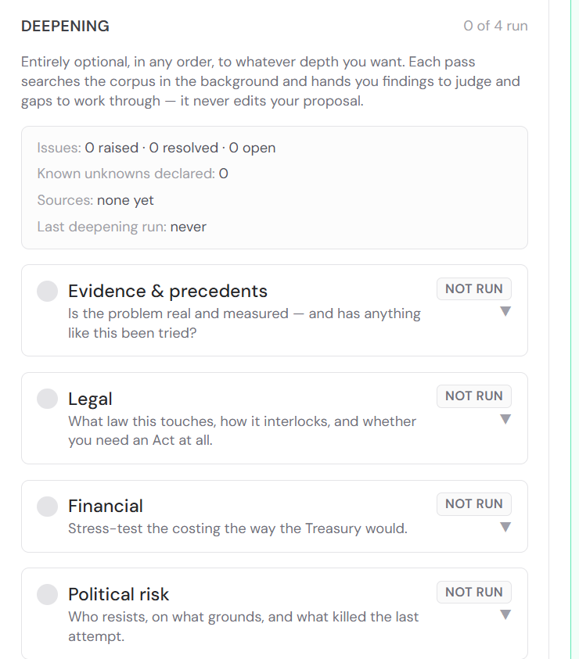
T
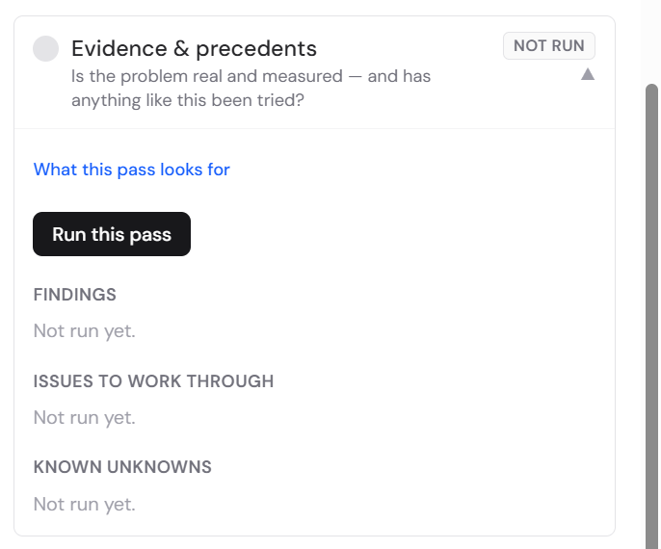
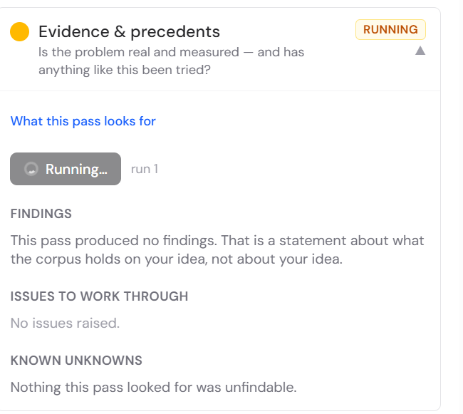It should not say these things while the pass is running (i.e. produced no findings, nothing was unfindable”) It should be blank while running till it finds something to say.
Also I can’t resize the panels width-wise
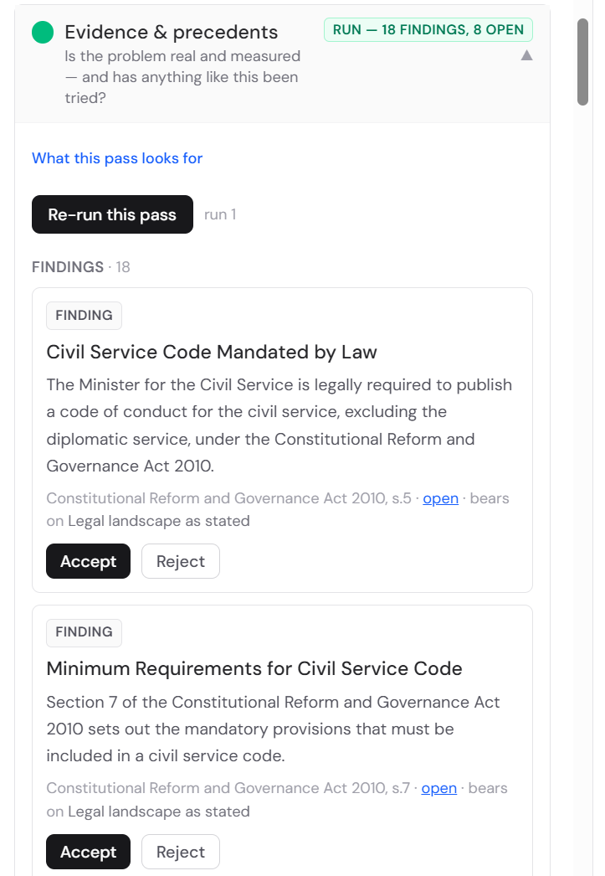
Evidence & precedentsIs the problem real and measured — and has anything like this been tried?Run — 18 findings, 8 open▲
What this pass looks for
Re-run this passrun 1
Findings · 18
Finding
Civil Service Code Mandated by Law
The Minister for the Civil Service is legally required to publish a code of conduct for the civil service, excluding the diplomatic service, under the Constitutional Reform and Governance Act 2010.
Constitutional Reform and Governance Act 2010, s.5 · open · bears on Legal landscape as stated
AcceptReject
Finding
Minimum Requirements for Civil Service Code
Section 7 of the Constitutional Reform and Governance Act 2010 sets out the mandatory provisions that must be included in a civil service code.
Constitutional Reform and Governance Act 2010, s.7 · open · bears on Legal landscape as stated
AcceptReject
Finding
No Plan to Change Basic Accountability Rules in 2012
In 2012, there was no plan to change the basic rules of accountability, which include a permanent, politically impartial civil service. However, there was a shared view among Ministers that responsiveness needed improvement.
CABINET OFFICE — Civil Service Reform Plan · open · bears on Pivotal obstacle
AcceptReject
Finding
Ongoing Concern Regarding Bureaucracy
As of August 2025, there are parliamentary questions directed to the Minister for the Cabinet Office regarding steps the Government is taking to reduce excessive bureaucracy within the Civil Service, referencing the Review Body on Senior Salaries' report.
Cabinet Office — Civil Service: Bureaucracy · open · bears on Who is affected / impact / cost
AcceptReject
Finding
Civil Service Leadership and Reform Inquiry
In July 2023, the Public Administration and Constitutional Affairs Committee (PACAC) welcomed an inquiry into civil service leadership and reform, indicating an ongoing focus on these issues.
Civil Service Leadership and Reform — CLR0002 · open · bears on Pivotal obstacle
AcceptReject
Finding
Constitutional Strain and Radical Change
The Public Administration and Constitutional Affairs Committee noted in October 2019 that the UK's constitution had been under increasing strain due to two decades of radical change, which could impact civil service operations and accountability.
Report: Work of the Committee since the 2017 General Election — Public Administration and Constitutional Affairs Committee · open · bears on Pivotal obstacle
AcceptReject
Finding
Accountability to the Public for Actions
The Relevant Authorities (General Principles) Order 2001 states that members should be accountable to the public for their actions and the manner in which they carry out their responsibilities, and should cooperate fully and honestly with any scrutiny.
The Relevant Authorities (General Principles) Order 2001, para.4 · open · bears on Pivotal obstacle
AcceptReject
Finding
Civil Service Effectiveness Inquiry 2017
In December 2017, the Public Administration and Constitutional Affairs Committee conducted an inquiry into Civil Service effectiveness, with evidence submitted on the need for effective change at all levels of government.
Civil Service effectiveness inquiry — CSE0005 · open · bears on Pivotal obstacle
AcceptReject
Finding
Civil Service Work: Key Themes and Preliminary Findings 2017
A May 2017 report by the Public Administration and Constitutional Affairs Committee on the work of the Civil Service highlighted key themes and preliminary findings, including skills, capability, contracting, commercial capability, and strategic thinking.
Report: 15th Report - The Work of the Civil Service: key themes and preliminary findings — Public Administration and Constitutional Affairs Committee · open · bears on Pivotal obstacle
AcceptReject
Finding
Sludgebusting Initiative to Simplify Government Processes
In March 2026, a Written Ministerial Statement was laid in the Lords regarding 'Sludgebusting: Simplifying Government Processes to Drive Delivery', indicating an ongoing government effort to address bureaucratic friction.
Cabinet Office — Sludgebusting: Simplifying Government Processes to Drive Delivery · open · bears on Who is affected / impact / cost
AcceptReject
Finding
Public Service (Integrity and Ethics) Bill [HL] Introduced
Multiple versions of a Public Service (Integrity and Ethics) Bill [HL] have been introduced in the House of Lords, with readings in October 2023, May 2024, and April 2026. These bills suggest a legislative focus on integrity and ethics within public service, which could relate to accountability structures.
Public Service (Integrity and Ethics) Bill [HL] — 1st reading (last updated 2023) · open · bears on Legal landscape as stated
AcceptReject
Finding
Public Service (Integrity and Ethics) Bill [HL] Introduced (2024)
A Public Service (Integrity and Ethics) Bill [HL] was introduced in the House of Lords on 7 December 2023, with explanatory notes relating to its provisions.
Public Service (Integrity and Ethics) Bill [HL] — 1st reading (last updated 2024) · open · bears on Legal landscape as stated
AcceptReject
Finding
Public Service (Ethics, Integrity and Independence) Bill [HL] Introduced (2026)
A Public Service (Ethics, Integrity and Independence) Bill [HL] had its first reading and was last updated in April 2026, indicating continued legislative interest in these areas.
Public Service (Ethics, Integrity and Independence) Bill [HL] — 1st reading (last updated 2026) · open · bears on Legal landscape as stated
AcceptReject
Precedent
Pensions Act 2004 - Codes of Practice for Public Service Pension Schemes
The Pensions Act 2004, section 90A, empowers the Regulator to issue codes of practice for public service pension schemes. These codes provide practical guidance for exercising functions under relevant pensions legislation and set standards of conduct and practice. This is a precedent for establishing formal codes of conduct and practice within a public service context.
Pensions Act 2004, s.90A · open · bears on Actions
AcceptReject
Precedent
The Pensions (Northern Ireland) Order 2005 - Codes of Practice
Article 85 of The Pensions (Northern Ireland) Order 2005 mandates the Regulator to issue codes of practice for functions under pensions legislation and standards of conduct. This serves as a precedent for establishing formal codes of conduct and practice within a public service context.
The Pensions (Northern Ireland) Order 2005, art.85 · open · bears on Actions
AcceptReject
Precedent
Civil Service (Special Advisers) Act (Northern Ireland) 2013 - Code of Conduct
The Civil Service (Special Advisers) Act (Northern Ireland) 2013, section 7, requires the Department to issue a code of conduct for special advisers within two months of the section coming into operation. The code must specify that special advisers cannot authorise public funds expenditure or exercise certain powers. This is a precedent for legally mandated codes of conduct for specific public service roles.
Civil Service (Special Advisers) Act (Northern Ireland) 2013, s.7 · open · bears on Actions
AcceptReject
Precedent
Consultation on PSFA Civil Penalty Powers: Code of Practice
A consultation on the Public Sector Fraud Authority (PSFA) Civil Penalty Powers: Code of Practice was opened in December 2025 and closed in February 2026. This indicates a process for developing and implementing codes of practice related to conduct and penalties within the public sector.
Consultation on the PSFA Civil Penalty Powers: Code of Practice (public-sector-fraud-authority) · open · bears on Actions
AcceptReject
Precedent
Digital Economy Act, Part 5: Data Sharing Codes and Regulations Consultation
A consultation on data sharing codes and regulations under Part 5 of the Digital Economy Act was conducted in late 2017. This demonstrates a process for establishing regulatory rules and codes of practice for specific government functions.
Consultation — Digital Economy Act, part 5: data sharing codes and regulations (government-digital-service, uk-statistics-authority, cabinet-office, hm-passport-office) · open · bears on Actions
AcceptReject
Issues to work through · 8 open of 8
The proposal mentions measuring the cost of decision paralysis by comparing government and private sector productivity. No source provides a methodology or existing data for such a comparison, nor does it quantify the 'total government spending' or 'annualised and capitalised' figures mentioned. This needs to be developed or sourced.
Work on this with LexMark addressedDeferDismiss…
The proposal states that the 'political cost of MPs not being able to deliver on their promises' is an impact. This is a qualitative statement without any quantitative measure or source provided. Further evidence or a method for measuring this cost is needed.
Work on this with LexMark addressedDeferDismiss…
The proposal asserts that 'everyone who wants to get something done is affected by the slowness and unnecessary friction of bureaucracy'. While some sources acknowledge bureaucracy as an issue, none quantify the number of people affected or the extent of this 'slowness and unnecessary friction'. This requires further evidence.
Work on this with LexMark addressedDeferDismiss…
The proposal suggests that 'taxpayers pay a large cost for that inefficiency'. While inefficiency is mentioned in some sources, no specific quantification of this 'large cost' to taxpayers is provided. This needs to be substantiated with data.
Work on this with LexMark addressedDeferDismiss…
The proposal states a need to understand the current legal landscape better regarding structural rules. While the Constitutional Reform and Governance Act 2010 mandates a Civil Service Code, the specific legal framework for 'formal accountability structure' as it relates to diffused responsibility and institutional inertia is not fully detailed in the provided sources. Further legal research is required to map existing accountability structures and identify gaps.
Work on this with LexMark addressedDeferDismiss…
The proposal's 'Actions' include 'Put the regulatory rules in place' and 'Draw up a strategy and plan for their implementation'. While precedents for codes of conduct and consultations exist, the specific content and scope of these 'regulatory rules' for addressing 'diffused responsibility' are not defined. The user needs to specify what these rules would entail.
Work on this with LexMark addressedDeferDismiss…
No retrieved source quantifies the scale of the problem. A proposal that cannot state how big the problem is will be asked to at the first committee sitting — find a number and cite it, or say plainly that none exists.
Work on this with LexMark addressedDeferDismiss…
Every finding supports the diagnosis and none contradicts it. That is possible, but it is also what a one-sided search looks like — worth a deliberate look for the strongest evidence against.
Work on this with LexMark addressedDeferDismiss…
Known unknowns
- No source quantifies the 'productivity of the government vs the private sector' or provides a methodology for this comparison as suggested in the proposal.Named by the pass as unfindable in what was retrieved.
- No source provides a direct measurement or quantification of the 'political cost of MPs not being able to deliver on their promises'.Named by the pass as unfindable in what was retrieved.
- No source quantifies the number of people affected by 'slowness and unnecessary friction of bureaucracy' or the extent of this impact.Named by the pass as unfindable in what was retrieved.
- No source quantifies the 'large cost' to taxpayers due to government inefficiency.Named by the pass as unfindable in what was retrieved.
- No source provides a comprehensive overview of the existing 'formal accountability structure' within the Civil Service that directly addresses 'diffused responsibility' and 'institutional inertia'.Named by the pass as unfindable in what was retrieved.
- No source provides details on what the 'regulatory rules' mentioned in the proposal's actions would specifically entail or how they would be implemented to address diffused responsibility.Named by the pass as unfindable in what was retrieved.
- While precedents for codes of conduct exist, no source provides specific details on the predicted costs or achievements of these comparable measures, nor any post-implementation reviews or evaluations of their actual impact on accountability or decision-making paralysis.Named by the pass as unfindable in what was retrieved.
More from Lex in the Deepening:
Issues to work through · 8 open of 8
The proposal mentions measuring the cost of decision paralysis by comparing government and private sector productivity. No source provides a methodology or existing data for such a comparison, nor does it quantify the 'total government spending' or 'annualised and capitalised' figures mentioned. This needs to be developed or sourced.
Work on this with LexMark addressedDeferDismiss…
The proposal states that the 'political cost of MPs not being able to deliver on their promises' is an impact. This is a qualitative statement without any quantitative measure or source provided. Further evidence or a method for measuring this cost is needed.
Work on this with LexMark addressedDeferDismiss…
The proposal asserts that 'everyone who wants to get something done is affected by the slowness and unnecessary friction of bureaucracy'. While some sources acknowledge bureaucracy as an issue, none quantify the number of people affected or the extent of this 'slowness and unnecessary friction'. This requires further evidence.
Work on this with LexMark addressedDeferDismiss…
The proposal suggests that 'taxpayers pay a large cost for that inefficiency'. While inefficiency is mentioned in some sources, no specific quantification of this 'large cost' to taxpayers is provided. This needs to be substantiated with data.
Work on this with LexMark addressedDeferDismiss…
The proposal states a need to understand the current legal landscape better regarding structural rules. While the Constitutional Reform and Governance Act 2010 mandates a Civil Service Code, the specific legal framework for 'formal accountability structure' as it relates to diffused responsibility and institutional inertia is not fully detailed in the provided sources. Further legal research is required to map existing accountability structures and identify gaps.
Work on this with LexMark addressedDeferDismiss…
The proposal's 'Actions' include 'Put the regulatory rules in place' and 'Draw up a strategy and plan for their implementation'. While precedents for codes of conduct and consultations exist, the specific content and scope of these 'regulatory rules' for addressing 'diffused responsibility' are not defined. The user needs to specify what these rules would entail.
Work on this with LexMark addressedDeferDismiss…
No retrieved source quantifies the scale of the problem. A proposal that cannot state how big the problem is will be asked to at the first committee sitting — find a number and cite it, or say plainly that none exists.
Work on this with LexMark addressedDeferDismiss…
Every finding supports the diagnosis and none contradicts it. That is possible, but it is also what a one-sided search looks like — worth a deliberate look for the strongest evidence against.
Work on this with LexMark addressedDeferDismiss…
Known unknowns
- No source quantifies the 'productivity of the government vs the private sector' or provides a methodology for this comparison as suggested in the proposal.Named by the pass as unfindable in what was retrieved.
- No source provides a direct measurement or quantification of the 'political cost of MPs not being able to deliver on their promises'.Named by the pass as unfindable in what was retrieved.
- No source quantifies the number of people affected by 'slowness and unnecessary friction of bureaucracy' or the extent of this impact.Named by the pass as unfindable in what was retrieved.
- No source quantifies the 'large cost' to taxpayers due to government inefficiency.Named by the pass as unfindable in what was retrieved.
- No source provides a comprehensive overview of the existing 'formal accountability structure' within the Civil Service that directly addresses 'diffused responsibility' and 'institutional inertia'.Named by the pass as unfindable in what was retrieved.
- No source provides details on what the 'regulatory rules' mentioned in the proposal's actions would specifically entail or how they would be implemented to address diffused responsibility.Named by the pass as unfindable in what was retrieved.
- While precedents for codes of conduct exist, no source provides specific details on the predicted costs or achievements of these comparable measures, nor any post-implementation reviews or evaluations of their actual impact on accountability or decision-making paralysis.Named by the pass as unfindable in what was retrieved.
The precedents that lex provides aren’t really precedents, they are a random search quite a lot of which are irrelevan.t Maybe search is still going to improve, we have quite a lot of work to do. But this seems like a poor search result than an intelligent search that has been properly sifted and the best rand precisely relevant answers produced. Instead of ranking the top 20 ‘for relevance’ which lex can’t seem to do very well, it should take the top 100 and pick out intelligently the ones that really are relevant and useful.
Lex’s !issues to work through” are much better quality and look genuinely useful. But it should be Lex critiquing it’s own work from a different angle to be really helpful

